**Summer Camps at Everton 1942**

There were five weekend camps all of which were held at Everton Scout campsite.

**6th-7th June 1942**

Present S.M.1 Wilson Hill

T.L.2 George Brown

P.L.3 Robin McDougall

S.P.L.4 James Morton

S.P.L. Alan Jubber

S.P.L. Alan Mackay

Transport By bicycle there and back. Treck5 Cart from Farm to Camp Site.

Tents Icelantic6,7 (newer) for 5 scouts

Wanderer7 for S.M.

Cooking All meals were cooked on wood fire except first half of Sunday’s dinner which was done by Primus.

Note: Primus (old, screened) would not boil potatoes so fire had to be used

Menue12 Tea:- Tea, bread, butter, fried sausage

Supper:- Ovaltine and biscuits

Breakfast:- Porridge, eggs, bead, butter, tea

Dinner:- Soup (3 tins Oxtail), Haggis and spuds.

Notes *Campsites were closed at 3pm, hence no tea on Sunday

*The ridge pole used on the Icelantic6 tent broke on Sunday forenoon. It was an old set of poles belonging to the old Icelantic tent8. The pole broke in two places and is unfit for repair and certainly not worth it. We still have one complete set of poles at the farm, though they are cracked.

Except for Sunday morning, the weather was quite good; dry and sunny. Sunday forenoon was wet, but cleared up at dinner time. There was a strong cold westerly wind.

The tents were quite dry when dismantled. All gear was taken back to the chest at the farm9, and none left in the locker10 at Everton, as we have not yet got a key for that locker (No. 7).

The camp was a very successful and enjoyable one, though there was not much time for recreation.

**20th-21st June 1942**

**Present** S.M. Wilson Hill (in charge)

Peewit Patrol11 Stuart Tosh

Alan Jubber

Roy Farling

John Ellis

Ronald Fraser

Jim MacIntyre

Duncan Kerr

**Transport**: All by bicycle, carrying kit. Treck5 Cart from farm to camp.

**Tents**: Icelantic6 and Wanderer

**Cooking** By wood fire [except Sunday’s breakfast] done in a “kitchen” built to the left (nearer burn) of the one used up till now.

**Meals** All meals were made up by each boy at home and brought in ‘packets’, one for each meal (a very successful idea).

**Menu** Tea:- Fried sausage, sandwiches, tea

Supper:- Sandwiches and ‘ovaltine’.

Breakfast:- Porridge, hard boiled egg, sandwiches, tea (cooked on a primus)

Dinner – Soup [tins of kidney, broth, chicken, oxtail and vegetable all mixed up]

Haggis [or fried sausage] and potatoes

Tea- Hard boiled egg, sandwiches and tea

**Programme**

On arrival (hot and sunny) – Erection of tents, making of kitchen and gathering of wood. In the evening (dull but dry) more wood gathered and stowed under the treck cart to keep it dry.

Sunday morning (Wet):- the boys were up and dressed at 5:30 in the morning, which was a pouring wet morning so breakfast had to be made by Primus stoves. Our troop was washing the breakfast dishes as the rest of the camp were awakening.

Sunday forenoon (Wet). Church parade to Inverkip church at which all but two boys attended, these two staying behind to make the dinner. Dinner was made over the fire using the wood from under the treck cart.

Sunday afternoon (dry) Swim in the pool14, at which three boys passed their First-Class13 swimming.

All tents taken down after they had dried and stored away.

Sunday evening. Campsite tidied and kit taken to farm before all boys cycled home via the Cloch.

Weather - it was wet, except for Sunday afternoon which fortunately cleared up for just long enough to let the tents dry and let us get them stowed away dry.

Tests Passed

1st Class Swimming:- Stuart Tosh, John Ellis and Ronald Fraser.

2nd Class cooking:- Roy Farling, Ronald Fraser and Duncan Kerr

2nd Class firelighting:- Ronald Fraser, Jim McIntyre

2nd Class axemanship:- Duncan Kerr, John Ellis and Ronald Frazer

Although the camp was wet, it was a very successful one.

**18th-19th July**

**Present** Wilson Hill (in charge)

Woodpigeon Jim Morton

Patrol Colin Reid

Austin Craigie (cook)

Edward Pearce

Visitors on Sunday Rev. Ian Dunlop

Jock Kerr

Gordon Graham

**Transport** By bicycle, kit by treck cart from the farm

**Tents** Icelandic and Wanderer

**Cooking** By wood fire for all meals. In place of the two logs used in other camps (and which had to be replaced every two meals) two large flat stones were used for cooking on, with iron bars between them (See sketch).

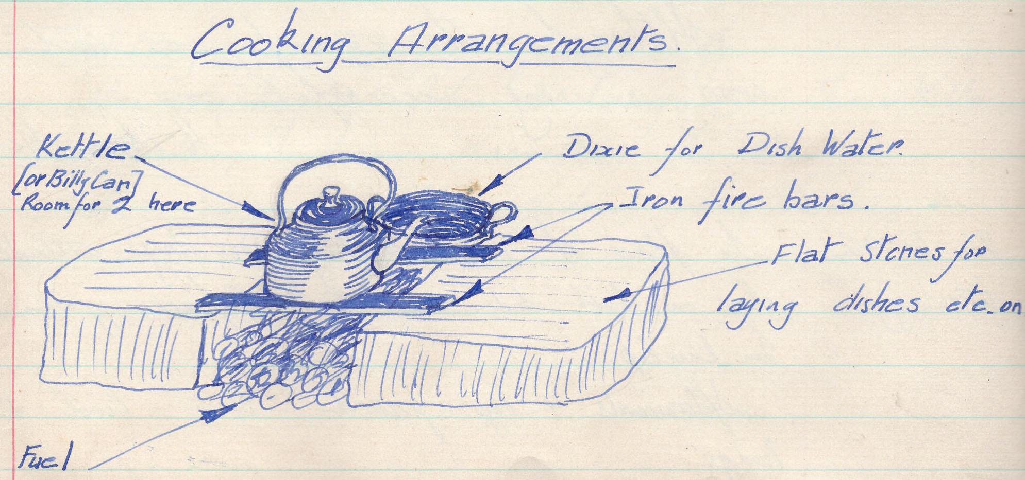

**Meals** The packet system, i.e. Each boy brought his own food made into a packet for each meal.

**Menu** Saturday’s tea Tea, sandwiches and sausages (or egg)

Supper Ovaltine and biscuits

Breakfast Porridge, bacon and egg. Rolls and tea

Dinner Soup, sausage, potatos and peas

Sunday’s tea Tea and sandwiches

**Programme**

**Saturday afternoon**

Tents put up and kitchen made

**Saturday evening**

Firewood gathered and sawen12 up into one foot lengths, then stowed under the treck cart to keep dry. Also, boys had a bathe in the pond, at which the raft there was improved by lashings three logs under it.

**Sunday Forenoon**

Inspection followed by a bathe in the pond then a walk up the woods and on to the moor to almost the Kelly Cut.

**Sunday afternoon**

Tents taken down (the Wanderer was taken down before inspection) and ground tidied up then kit packed on to the treck cart. At this time, Mr. Ian Dunlop15 arrived to see us, followed by Jock Kerr and Gordon Graham (who had walked down from Greenock).

After early tea, all went for a walk through the woods, when the boys went off by themselves. ( When Ian Dunlop and I returned, we found various parts of our kit hung up on high branches of trees; the handiwork of the boys who had returned earlier).

**Sunday Evening**

All kit taken to the farm and boys then cycled home.

Weather was very good (for Everton), the only rain was a short shower in the forenoon. A most enjoyable camp.

P.S. Austin Craigie passed his first-class cooking [Examiner SM David Thomson].

Author Wilson Hill

**1st-2nd August 1942**

**Present** S.M. Wilson Hill (in charge)

**Fox Patrol** P.L. John Menzies

Fraser Millar

Campbell Conn,

Gordon Graham

Jock Kerr

Andrew Webster

Eric Duncan

Transport, tents, cooking and gathering firewood were as for the last camp. Weather was dry all weekend, making this the first dry (i.e without any rain at all) weekend camp for some years.

The swimming pool was in constant use and John Menzies and Andrew Webster passed their first-class swimming test.

On Saturday evening, there was a campfire conducted by the D.C. Our troop rendered “Chin Gan Goo”.

On Sunday forenoon, there was a Scout’s Own held at the Indicator.16 The service was conducted by a Barrhead Scouter, who gave us an excellent address on cleanliness.

All tents and kit were stowed on the treck cart by 3 o’clock after which we did some stalking in the woods behind Everton. Two (or three) boys went forward and selected a good hiding place from where they gave the hoot of an owl at regular intervals; the others had to get as near to them as possible without being spotted.

A very successful and pleasant camp.

Author Wilson Hill

**22nd-23rd August 1942**

**Present** S.M. Wilson Hill (down on Sunday morning)

T.L. George Brown

2nd Andrew MacMillan

Ian Conn

The cat was under the charge of T.L. George Brown.

Weather was fairly good, dry during the day but wet during the night.

Paraffin was needed to get the morning fire going as the wood was very wet.

Andrew McMillan and Ian Conn passed first-class cooking tests (examiner S.M. William Dally).

A padlock was fixed to the troop’s locker in Everton hut (Lock number 7).

Tent used was the Icelandic.

Unfortunately, the photographs taken of the last two camps were spoiled by S.M. W. Hill mixing up two films and doubly exposing one of them.17

Author Wilson Hill

**Saturday 17th October**

**Treck cart brought back from Everton**

Four scouts under 2nd Andrew McMillan brought the treck cart and the following kits back from Everton, via the train.

Treck Cart

2 Icelandic tents with poles

1 Wanderer tent with poles

Large and medium groundsheet

2 Primus stoves, also paraffin and meths

Ambulance Box

S.M.s Camp Bed

Kettle

100 ft white cord

Scout flag

**Saturday 12th December 1942**

Cycle run to Everton to complete list of kit in chest.

P.L. Andrew MacMillan, SPL Ian Conn, SPL Jim Morton and S.M. W. Hill cycled to Everton and checked the kit in the troop chest at Everton Farm

Editor’s notes

1. S.M. stands for Scoutmaster

2. T.L. stands for Troop Leader. This was an older Scout (aged 17 or thereabouts) who had been a Patrol Leader and may or may not have retained his patrol once he was promoted to T.L. The Troop Leader often took on some of the responsibilities of an assistant Scoutmaster.

3. P.L. stands for Patrol Leader (usually aged 16-18 years old but could be younger).

4. S.P.L. stands for Second Patrol Leader (also called Second or Seconder). This was the equivalent of Assistant Patrol Leader, but those concerned were older than current APLs a Scout could remain in the Scout troop until aged 18 years old.

5. Wilson Hill’s spelling. The spelling in later logs was ‘Trek Cart’. The trek cart had two wheels and two handles and was pushed/pulled by several Scouts. It was used to transport gear and other loads.

6 Wilson Hill often spelt this tent as “Icelantic”. In fact, it was ‘Icelandic’.

7 The Icelandic and Wanderer tents are clearly visible in two of the photos taken for the camp of 6th-7th June

8 The state of the poles suggests that at least one of the Icelandic tents had been used for a substantial period – possibly dating from the 1930s when the troop was founded.

9 The farm just below Everton was regularly used by the 70th to store equipment. How this link was established is not yet known.

10 The lockers were in a three-roomed wooden hut (visible in one of the photos taken on the 6th-7th July camp). The hut was rather basic and was only used for sleeping in if Scouts were ‘washed out’ of their tents. The hut was destroyed by arsonists on the same evening that the Cornalees Centre was set on light.

11 A patrol log for the Peewit patrol still survives that covers the period 1943-1945. The Peewit patrol only existed during the period 1942-1945 and was initiated on 13th February 1942 (as stated in the Troop Log). It was initially made up of boys from the Cardwell Bay district who all came up from the Cubs together (Stuart Tosh, Alan Jubber, John Ellis, Roy Farling, Jim MacIntyre, Eric Duncan, Duncan Kerr). Stuart Tosh was the first Patrol Leader, followed by Alan Jubber. The existence of the Peewit Patrol was not appreciated until the Troop Log (1939-1943) was discovered.

12 Spelling used in the troop log

13 Scout programmes at the time placed a heavy emphasis on learning Scouting skills through a progressive training scheme. Scouts started with the Tenderfoot badge which usually took about a month, followed by the Second Class Badge which could take 1-2 years or more. The first class badge was supposed to be the target for all scouts. In practice, it was quite a challenging badge to earn, especially as the Scouts at this time had to be tested by a Scouter from another troop. The ultimate goal was the King Scout’s Badge.

14 One of the main reasons for building the pool at Everton was to allow Scouts to attempt the swimming test for the First Class Badge. The only swimming pool in Greenock at the time was a private club in the building on Campbell Street that eventually became the old Arts Guild.

15 Ian Dunlop played an important role as Scoutmaster and Group Scoutmaster during the 1930s. He was a minister and had to leave the troop when he was called up in 1939.

16 An indicator that identified landmarks from Everton Camp. A picture of it was taken on 16th March 1940 during a day visit/hike to Everton.

17 Wilson Hill was a keen photographer and processed his own photographs. Wilson Hill was a member of the 70th from its early days in the 1930s up until 1945. Unfortunately, the troop log books for this period are no longer in the Troop’s possession (other than the Troop log from 1939-1943). This is unfortunate as there is a very good chance that more of Wilson’s photographs adorn those publications.