Chapter 4 Programmes, Activities and Competitions (1932-39)
4.1 Introduction
In the absence of Troop Logs, it is impossible to know what a typical Troop evening was like during the thirties. Far more is known about Troop meetings during the war years and it is possible that these were run on similar lines to those of the thirties. Details are given in Chapter 6. Similarly, there is virtually no information relating to hikes, weekend camps or other outdoor activities. However, there are several references in the COH minutes relating to camping equipment and storage, and this in itself implies that camping activities were carried out. Further information is given in Chapter 7. By contrast, there is some useful information on Summer Camps, which was provided by a short pamphlet printed in 1992. This was based on accounts taken from old Troop Logs when the Logs were still in the Group’s possession. This is also covered in Chapter 7.
Although details of Troop programmes and activities are currently unavailable, the COH minutes provides some interesting information on a number of aspects such as the Troop's involvement in competitions and parades. These are described in the following sections.
4.2 Competitions – Why have them?
Competitions have generally been popular with Scouts, whether they be within the Troop itself or between different Troops. No doubt some educationalists would throw up their hands in horror and claim that the losers' self esteem is bound to be irrevocably damaged. Such arguments may have some foundation, but they can be taken far too far. Scouts have always been enthusiastic about competitions, challenges, games and wide games - the rougher the better. Or at least most have! Certainly in the thirties, few would doubt that competition was good for you. It's said that the best way of fattening pigs is to let them compete for their food. If they are fed separately and allowed to eat as much as they like, they eat less and don't get so fat. In the same way, competition can stimulate and motivate people to do better than they might have done if left to their own devices. Competition is also just as much about teaching Scouts how to lose as to win. It is the way that competitions are handled that is crucial. In an ideal world, all winners would be magnanimous and generous in their praise of those they compete against.
The minutes of the Court of Honour demonstrate that the Troop regularly took part in various competitions organised and run at District or County level. These were all taken very seriously and the patrols that entered committed themselves to specific training in the months leading up to each event.
4.3 The Shannon Cup
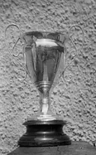
For many years, the Shannon Cup (Fig. 3.1) was the most prestigious camping competition run by Greenock District Scouts, before it was superseded by the Hardie-Webster trophy in the Seventies. The cup was donated by Mr. Shannon who owned the shop of that name and who was the official Greenock stockist for all Scout uniforms after 1933. His son had been killed in the First World War and the cup was probably donated in memorial of him. It is not known which year the 70th first entered the Shannon Cup competition, but the Troop certainly won the trophy over the weekend of the 25th-26th May 1935 - a remarkable achievement for such a young troop that had only been in existence for three years. Some details of what was involved were provided in an article in the Greenock Telegraph. The teams reported to the Everton Hut at 3 pm on the Saturday. All boys were to carry a bible, and the Patrols were to arrange their own menus and food. Breakfast had to include porridge and eggs, while dinner had to include stew with one vegetable, and a milk pudding. Patrols had to lay out a camping site, set up a kitchen and build the necessary gadgets. There were also tests on ambulance, signalling and cooking skills. The examiner was Mr. Andrew McKechnie, assisted by William Whiteford and the final scores were;
1) 30th Greenock (70th) 147
2) 32nd 140
3) 10th 128
4) 28th 117
5) 33rd 100 Figure 1 The Shannon Cup
The winning patrol was led by Alan Hardie who recalled the Cup being presented to both him and the Scout Master/Group Scout Master Ian Dunlop at Seafield House - the HQ for Greenock Scouting at that time. Unfortunately, he does not remember for certain who was in the winning Patrol, but he thought that Eoin Steel was included and possibly Ian Blake, Lawrence Harvey and Ronald Grant. There was a short article in the Telegraph describing the presentation event which praised the 70th's victory as being 'particularly satisfying' since the troop had only started up in 1932. The District Commissioner presented the Cup on the 18th June 1935.
Another patrol from the 70th was entered for the Cup in 1936, but failed to regain the trophy. Unfortunately, it is not known who was in the patrol or who was leading it. P.L. Wilson Hill was meant to lead a patrol in 1937, but he and the patrol had to withdraw before the event took place. There is no record of whether the Troop competed in 1938, but a patrol that was entered in 1939 had to withdraw prior to the event due to examinations. There was also the thorny issue of the competition clashing with the Sports Day for Greenock Academy. Most, if not all, of the 70th Scouts would have attended Greenock Academy, and, if the Thirties were anything like the Sixties or Seventies, the chances of any Scout avoiding Sports Day were zero! Whenever, there was a clash between a school event and a Scout event, the Scout event always came off second best.
It is surprising that the Court of Honour minutes did not record the 1935 victory, especially since 70th success in the Shannon Cup has been rare. Indeed, the Troop only won the Cup on three occasions over the many years that it ran. As the educationalists say, competition is a bad thing!
4.4 The County Flag
The County Boy Scout Association ran a competition which was called the County Flag. It appears that each District in the County was allowed to enter one Patrol for this. This meant that Greenock held a separate competition of its own to decide which Patrol should represent the District. Like the Shannon Cup, the Troop had some early success in this with a 70th Patrol being chosen to represent the District in March 1935.
It is not exactly clear what the County Flag involved during the Thirties. In more recent years, it has been a camping competition, but the records suggest that a more compex competition was organised in the Thirties. There was a first stage where a team of Leaders from 'up County' inspected a Troop meeting held by each competing Troop. There was then a 'second stage' where each Patrol entered by the competing Troops was examined during a weekend camp. The whole process several weeks or months to carry out, and it looks as if the results of these inspections were conveyed back to Troops in September of each year. There are several puzzling aspects to the County Flag. The records do not define what the inspection of the Troop meeting was about. What was being tested? Were the examiners only looking at the Patrol that was entered, or the Troop as a whole? Were they marking how well the Patrol or Patrols functioned, or were they marking the Troop’s programme, the facilities, discipline, uniform standards or what? It's all a bit of a mystery!
The winner in 1935 was a patrol from the Barrhead Scouts. Having missed out on the Flag, the 70th tried again in 1936 with a Patrol led by Eoin Steel. A Port Glasgow Scoutmaster judged all the Greenock Patrols that had been entered and the 70th Patrol was once again successful in being nominated as the District's representative. There then followed an inspection of a 70th Troop meeting by a County Examiner on Friday 24th April 1936. However, things did not go well! When the examination report appeared in September, it stated that 'the material of the Troop was promising, but that there was a slackness in leadership'. This led to some gnashing of teeth amongst the Leaders and a lot of soul searching within the Troop. The upshot of this was quite a radical shake up in how the Troop was run and training was carried out, some of which is described in section 4.9.
There was also an element of getting one's fingers burnt. From then on, the Troop was wary of taking part in the County Flag again. The details of the examiner’s report are not recorded, but one of the criticisms leveled came to light in December. This involved the meeting place itself, with Finnart Church Hall being judged too small for Troop meetings. This was certainly true, but there was little the Troop could do about that, and so it was decided that there was no point entering the County Flag until the rules were changed. Consequently, the Troop did not enter again until 1943.
As the educationalists say, competition is a wicked, evil thing!!
4.5 Scout Swimming Galas
If the Troop had a patchy performance with the Shannon Cup or the County Flag, it positively shone at the District Swimming Gala - a two hour event held annually on a Friday evening during the first half of June at the West End Baths (the old Arts Guild building in Campbell Street). The event was clearly an important item on the Scouting calendar, and was watched by local dignitaries and Scouting V.I.P.s. The Provost and his wife were regular attenders as were H.W. Butter (the District Commissioner), Ryrie Orr (the President of the Greenock Boy Scout Association), Colin Finnie Jr. and James Swan (A.D.C. for Wolf Cubs). Other V.I.P.s who attended during the Thirties were the Rev. Troup, Lord Beresford, Colonel Hewieson, and the Rev. Alex Philp (Chairman of the Greenock Boy Scouts Association). The event was usually written up in the Greenock Telegraph the day after, with a report on any speeches that were made.
There is no record of the Troop entering in 1933, but it is possible that the troop entered in 1934 and came second in the Victory Trophy. There is an element of doubt, however, since the report mentioned the 30th Renfrewshire, and not the 70th Renfrewshire. This may have been a mistake on the part of the Telegraph and the 30th Greenock/70th Renfrewshire was intended. However, the troop certainly entered every year from 1935 onwards and always did well.
There was a range of competitions in the Gala, but the three main championships were for Cubs (1 length), Scouts (2 lengths) and Rovers (4 lengths). Championships were also held for the Brownies and Guides, while other events included a diving championship for Scouts, a Scout novices race consisting of one length of the pool, and team competitions. Various fun events were also introduced in different years such as an underwater race for Scouters, pyjama races, Scouters races, boat races, ladies races and handicap races. Other events and displays were laid on purely for entertainment. In 1938, the Sea Scouts put on a regatta with paddle 'steamers' that they had constructed. Polo matches between local polo teams were a common feature, and in 1939 there was a diving demonstration by the "Wonder Diving Twins".
However, the most prestigious event of the gala was the Victory Trophy - a team event involving lifesaving, diving and a team race. This was the blue ribbon event and, throughout the thirties, the 70th and the 59th vied with each other for this principal honour. The 70th won it on three occasions (1935, 36, & 39) while the 59th won it in 1937 and 1938, with the 70th coming second each time. As already stated, the 70th may have come second in 1934 to the 5th Renfrewshire.
In 1935, the 70th came away with both the Victory Trophy, and the individual Scout Championship. Unfortunately, the records do not state what Scouts were present in the Victory Trophy team, but it is highly likely that Alan Hardie and Eoin Steel were both involved. The former certainly won the Scout Championship of 1935 and dominated swimming events for several years after. In 1935, a special prize was awarded to a Wolf Cub for his 'splendid but not quite successful' effort in the Cub championship; a lifeguard had to eventually dive in and retrieve him.
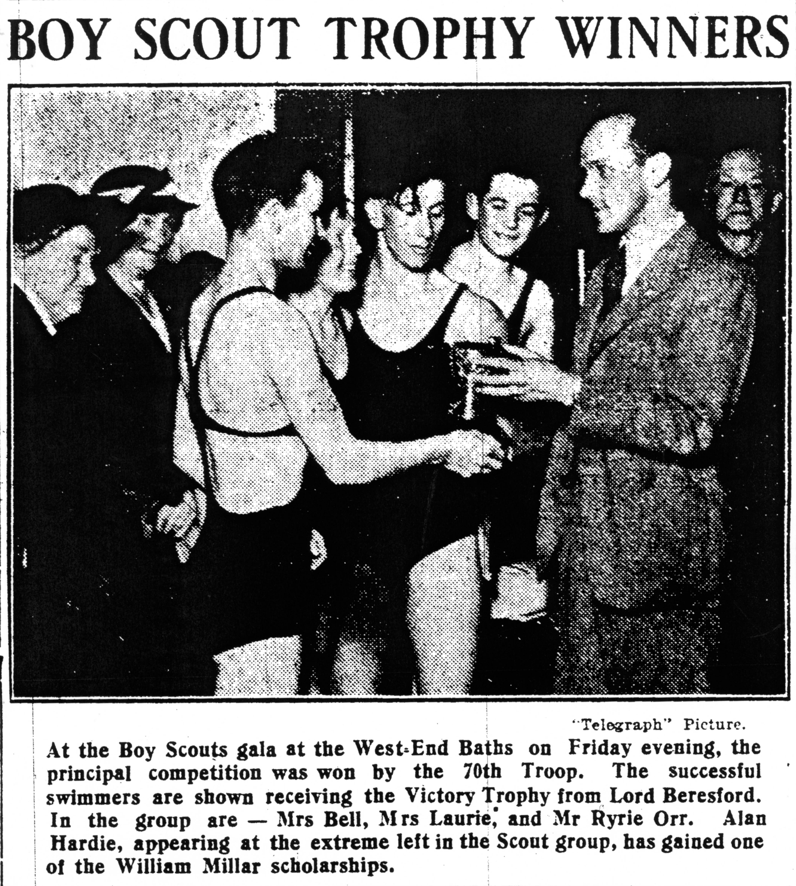
In 1936, there was a record entry which required various heats to be run. Nevertheless, the 70th retained both the Victory and Scout Championship trophies. Alan Hardie won the Scout Championship again and presumably led the team that won the Victory trophy since a Greenock Telegraph photograph showed him receiving the trophy from Lord Beresford - a prominent supporter of Scouting in the District (Fig. 2). From the photograph, it is clear that Eoin Steel was a member of the team, and possibly Dick Leggett. The fourth member of the team is more difficult to identify.
In the 1937 gala, J. Buchanan won the Scout novice race, Alan Hardie won the Rover Scout race, and the 70th Rover Scouts won the Rover Team race. Unfortunately they had to yield the Victory trophy to the 59th, but they still came second.
Figure 2 Presentation of the Victory Trophy in 1937.
In 1938, the 70th again came second to the 59th in the Victory Trophy. As compensation, Alan Hardie retained his title for the Rover championship while Scout Alan McKay won the novice race. The 70th also won a group race, but it is not known which individuals competed in this. It should also be noted that Ian Dunlop was on the organising committee for both the 1938 and 1939 Galas. Ian was an important member of the District Leadership team on top of his duties with the 70th.
In 1939, the troop won the Victory Trophy for the third time with a team consisting of Dick Leggett, Ian Curtis, Jim Buchanan and Ronald Mackay. The novice cup was won by John Menzies and the Rover cup was won by Eoin Steel. who also organised the preparation and training. Figure 3 shows some of the 70th Scouts who participated in the Swimming Gala during the Thirties and achieved success. The educationalists are daft. Competitions are excellent!!

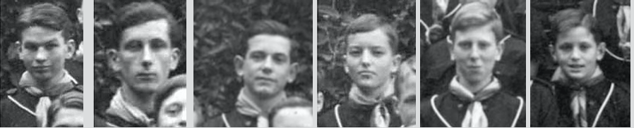
Figure 3. Known participants in the Swimming Gala (Alan Hardie, Eoin Steel, Dick Leggett, Ian Curits, Jim Buchan and John Menzies)
In 1937, Greenock was invited to send a District swimming team to take part in a relay race at the Glasgow Scout Swimming gala at Cranstonhill Baths on the 29th January. The team of four Scouts included Dick Leggatt of the 70th who was fastest over the 50 yards at 28.4 secs. There were four teams in the relay from different areas - Glasgow, Renfrewshire (represented by Greenock), Dumbarton and Edinburgh. The Greenock team performed well but failed to win against stiff competition. A relay team was also entered for the Glasgow Gala on 1st April 1938, again with Dick Leggett in the team. It was the youngest team competing and, despite not winning, they must have done reasonably well since there was a request from the County Secretary that two Greenock Scouts form half the County team that would compete in the Stirlingshire Swimming Gala. It is not known how this team performed, but there is a good chance that Dick Leggett may have been one of the two Scouts picked.
As can be seen above, the 70th took the Swimming Gala very seriously and made a point of practicing beforehand. From 1936 onwards, this involved travelling up to the Port Glasgow Swimming Pool since that was the only indoor pool available for practice during the Thirties. The Court of Honour regularly approved a sum of 7/6 for bus travel and pool entrance. One might ask why the West End pool was not used as that was much handier. In fact, this was a private club and one had to be a member to swim there. Presumably, Greenock District had a special arrangement with the Swimming Club in order to hold the Swimming Gala there.
The West End Pool was heated, but the water was pumped directly from the Clyde. Considering the pollution that must have been around at the time, it was possibly a good thing that it eventually closed and was converted into the Arts Guild! The only other swimming pools close by were the outdoor pools at the Battery Park (there is a photo of it in the Greenock Telegraph of 2nd Aug 1937) and in Gourock. Both were unheated. The former was described as 'warm and dirty', while the latter was described as 'cold and clean.' This was related to the number of people using the two pools! The Battery Park pool was closed in the Sixties, while the Gourock pool (now heated) lives on and has celebrated its centenary.
During the Thirties, the District was keen to encourage swimming for Scouts. The pool constructed at Everton campsite was one such initiative. Another was the 'Otters' Club which was created such that Scouts could learn how to swim and/or improve their swimming standards. The Club catered for all Scouts and all abilities and proved a great success, leading noticeable improvements in performances at the Galas. Port Glasgow Swimming Pool was used during the winter on Monday evenings at 6-7 pm, and the outdoor Gourock pool was also used in the summer. The Club was running in 1934, but appeared to stop at some point, for J. J. Swan proposed that it be restarted in the autumn of 1937 with 36 interested Scouts and Scouters. Members were entitled to wear a club badge if they were able to swim 50 yards, dive from a height of 6 feet; surface dive in a depth of at least 4 feet and pick up an object from the bottom. The club badge and colours included 'The Scout Sports Badge with letters OSC beneath on a royal blue background’. The yearly subscription was 6d per member. The officials for 1937-38 included J. J. Swan (Captain) and Ronald Grant (Secretary). It is not known whether the latter was the 70th's Ronald Grant or not. The club was certainly still running in 1940, despite the war.
4.6 Football Shield
In November 1937, a Mr. Dally visited the Court of Honour to invite the Troop to enter a football league that had been run by the District for several years, and which was associated with a Football Shield that was awarded to the winners. Teams were limited to Scouts aged 11-16 and each match cost 6d. However, there was a feeling amongst the 70th P.L.s that most of the Scouts would be playing school rugby on Saturdays and that it would be difficult to get a team. Nevertheless, it was decided to mention the project to the Troop in order to guage their reaction. Lawrence Harvey was elected to take responsibility if any team should transpire since 'he appeared to know something about the game'. In fact, the proposal actually did gain approval from the Troop, which demonstrated that the Court of Honour did listen to the Scouts. It was probably too late to enter a team for the season 1937/38, and there is no evidence of a 70th football team over the next 10 months. As a result, the Court of Honour were not particularly interested in entering the Shield when the time came to apply again in October 1938. This must have caused a minor rebellion within the Troop, for at the next Court of Honour in November, Jim Crawford called for a motion to overrule the previous decision, and was seconded by Ian Munro. A committee was then set up consisting of Ian Curtiss, Nicol Smith, Ian Munro and A.S.M. Eoin Steel to 'govern' the 70th's team. A discussion then ensued about obtaining a football, and two proposals were put forward:
a) 'that the troop should supply a new ball out of Troop funds' or
b) 'that a ball in moderately good condition belonging to Scout Jim Buchanan be renovated at the Troop's expense'.
A poll was held and the latter option was favoured. It was also decided that football jerseys should be purchased by the Troop in Troop colours. The team itself would pay for the hire of football pitches. A team did indeed get formed and went on to draw one game and gain a walkover in the next game when the opposition failed to turn up. The ball was now reported to be in a 'playable condition'. and jerseys were in hand. However, by the New Year, initial enthusiasm had waned and the team was struggling to get a full 11 players. This was not entirely unexpected since a full team would have required almost half of a troop who predominantly played rugby. They lost their next game 3-0, but still managed to win another game 2-0 with only 9 players. The Shield that season was eventually won by the 33rd Troop. The Shield continued to be played in some of the war years (for example 1943 and 1944), but there is no record of the 70th taking part. In 1944, the Scouts eligible to play had to be aged under 15.
4.7 Other District Competitions
At his meeting with the COH in November 1937, Mr. Dally also raised the possibility of a cricket competition in the summer of 1938 with a trophy as a prize. The Court was far more enthusiastic about that idea (no doubt since it was a core school sport at Greenock Academy) and elected to enter. However, there is no record of this competition ever taking place.
Mr. Daly also mentioned a Scout Display which was to be held after the next Cub Display - the latter was presumably a regular event. About 12 troops were to take part with each Troop presenting an item and then there would be a mass sing song. The Court decided to participate, but the event was cancelled.
Other District competitions that were running in the Thirties were the Public Service Vase on first aid (later to be renamed the Drummond Vase), and the Fire Shield on fire fighting and rescue techniques. There is no evidence that the 70th entered either of these, but then there is no evidence that they did not!
In 1938, the Fire Shield was open to teams consisting of 1 P.L. plus 6 Scouts. The Scouts had to be 16 or under, but could be from different patrols. Each team had to be able to run out a hose, connect the hydrant to the fire plug, and direct jets through a hoop or a target, then dry out the hose, dismantle everything and pack up. Each team also had to be able to render first aid, enter a burning building and rescue a person using the fireman's lift and do artificial resuscitation by the Schaffer method. Evidence from District records reveals that there was about a month's training leading up to this. In 1944, the entrants were also required to use a fire extinguisher and stirrup pump, and be trained in dealing with incendiary bombs!
A Scout Sports Day was held at Everton campsite on the 13th June 1936 to mark the completion of the swimming pool. Prizes were funded by the Cub Council, and the events included a 50 yard sprint, high jump, long jump, marathon, tug-o-war, relay race and 5-aside football. It seems highly likely that the 70th were involved in this and may even have won some of the prizes.
The District records mention a couple of competitions and Cups which may never have run. These included a Cup that had been donated in 1933 by former D.C. Hector Russell called the Joe Esplin Memorial Cup, a Cricket Trophy that was gifted by D.C. Waller Butter and approved in 1937, and a Duke of Conaughts Shield for Marksmanship which was mentioned in early 1938.
4.8 Inter-troop Challenges and Activities
There is some evidence that informal inter-troop activities were fairly regular occurrences during the Thirties and Forties. The 70th had a particularly close relationship with the 6th Renfrewshire Scouts (1st Gourock, Colonel Darroch's Own) based presumably at Ashton Church. Indeed, in 1940, it is reported that an English Scout who volunteered to help with the 70th's Wolf Cub Pack joined the 1st Gourock Scouts by mistake, thinking that they were the 70th!
It is also known that the troops leant each other camping equipment on occasions. In the Forties, there were shared Troop meetings and wide games, which probably occurred in the Thirties too. It is certainly known that the 70th Troop's first Summer Camp in 1933 was a joint camp with the 6th. It is possible that there were similar activities with other troops. For example, ten Scouts from the 70th visited the 38th Renfrewshire on 12th February 1937, in response to a challenge to a game of handball!
4.9 Competitions within the Troop
In September 1936, the troop received critical reports from the County Flag and Shannon Cup examiners on leadership and training standards. As a result of this, Ian Dunlop decided to increase standards by intensifying the patrol system in a number of ways. One of these was the introduction of a patrol competition on the first Friday of each month - a competition which would include patrol items at the Troop campfires. Inspections would also be held each night. The winning Patrol would be given the honour of leading the monthly church parade, and be given custody of a small pennant. The Wolf patrol won the first Patrol competition held in September 1936. A few months later in February 1937, Ian Dunlop donated a Cup to the Troop (aptly called the GSM's cup) which would be contested each year. The rules were recorded in the COH minutes as follows:
* The competition will be held every year at such time as the Court of Honour shall determine.
* The subject for competition shall be as the COH and the S.M. shall determine and will normally be part of the Second or First Class Badge, this being altered every year. The rules for the competitions shall be as in the current issue of POR for the section tested.
* Only Scouts (not P.L.s or Seconds) may compete. The P.L.s with the help of the S.M. shall decide the best Scout in each Patrol and these Scouts shall be tested by an external examiner (or by the G.S.M.).
* The examiner shall be appointed by the Court and S.M.
* The initials of the winner and the year shall be inscribed on the Cup at the winner's cost and the Cup shall be presented to the winner in the presence of the Troop.
The first competition took place in April 1937 and involved Second Class ambulance skills. The winner was a young Harold Hastie of the Wolf patrol. Not long after his success, he was promoted to Second. In 1938, the competition was on morse and semaphore, but it is not recorded who won it. In 1939, the competition was on Tenderfoot and Second Class knots. This time Duncan MacKenzie of the Woodpigeon patrol (later to become MacKenzie the Jeweller) won it.

