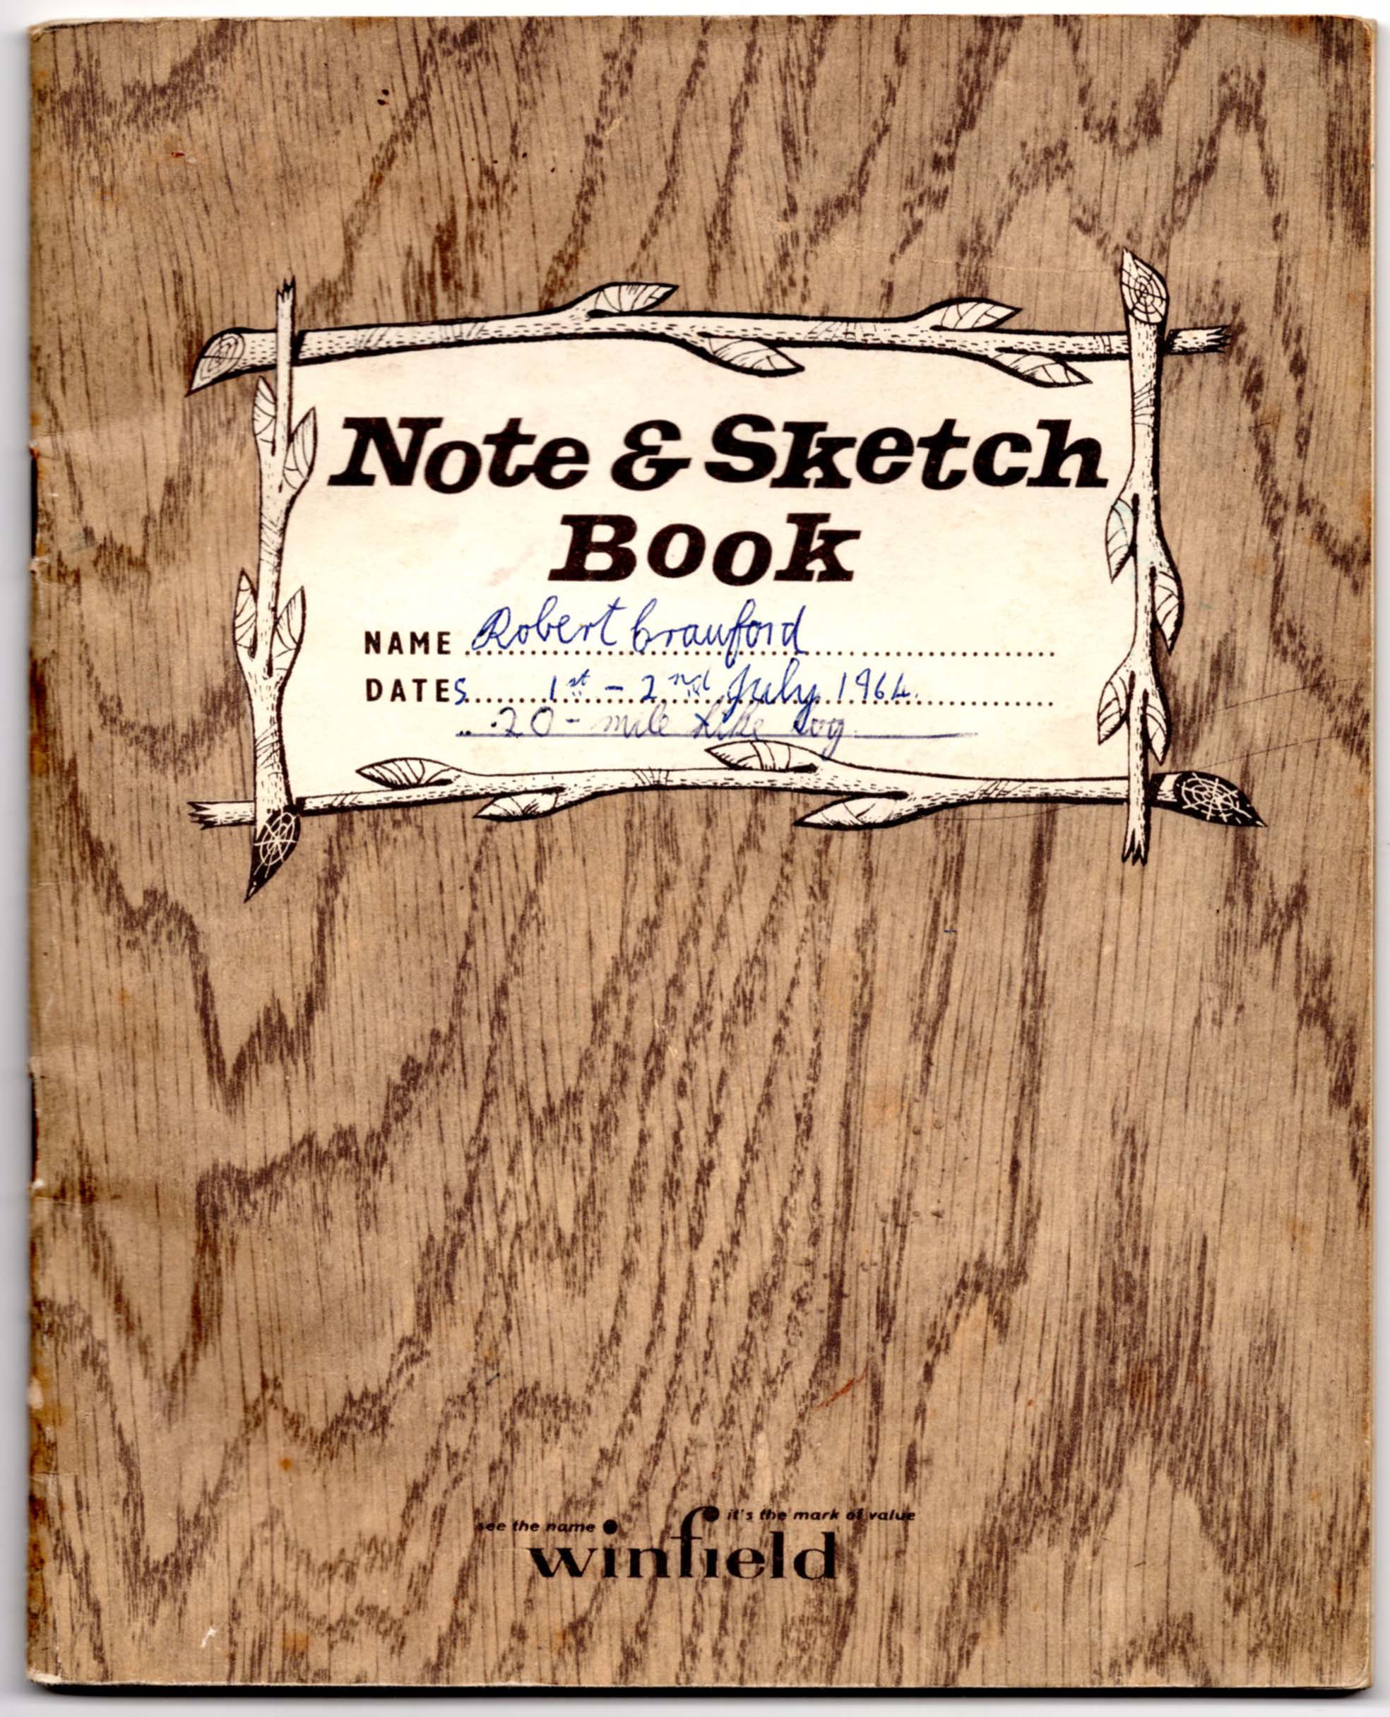

The following is a transcript of the original log. The description includes the timings and distances that were originally in separate columns on each page. The diagrams are scans of the originals.
The hike was assessed by the Rev. J. McCallum Young, but it is not clear what it counted towards. One possibility is the Explorer Proficiency badge.
Page 1
Wednesday 1st July – Thursday 2nd July 1964

Twenty mile hike log

Written by Robert Crawford

Participants in the hike:-
Bobby McCallum
and
Robert Crawford

To:- Rev. J. McCallum Young

70th Renfrewshire
30th Greenock
Finnart’s Own

Written with imagination –
Passed!

….. Young
Oct. 1964

Page 2

Equipment carried

Myself Bobby

1 dixie 1 dixie
Elastoplast map and compass
Spare map rest of the food
Part of the food personal kit
Personal kit
Tent and groundsheet

Weather experienced

On Wednesday, it was very hot but with a cool breeze. While we were walking along the Forestry Commission Road through Glen Fyne, however, the wind was cut off by the trees and we became very sunburnt. We awoke to clouds on Thursday morning and it soon began to rain. Later on in the morning, the rain stopped but the sun never managed to break through.

Page 3

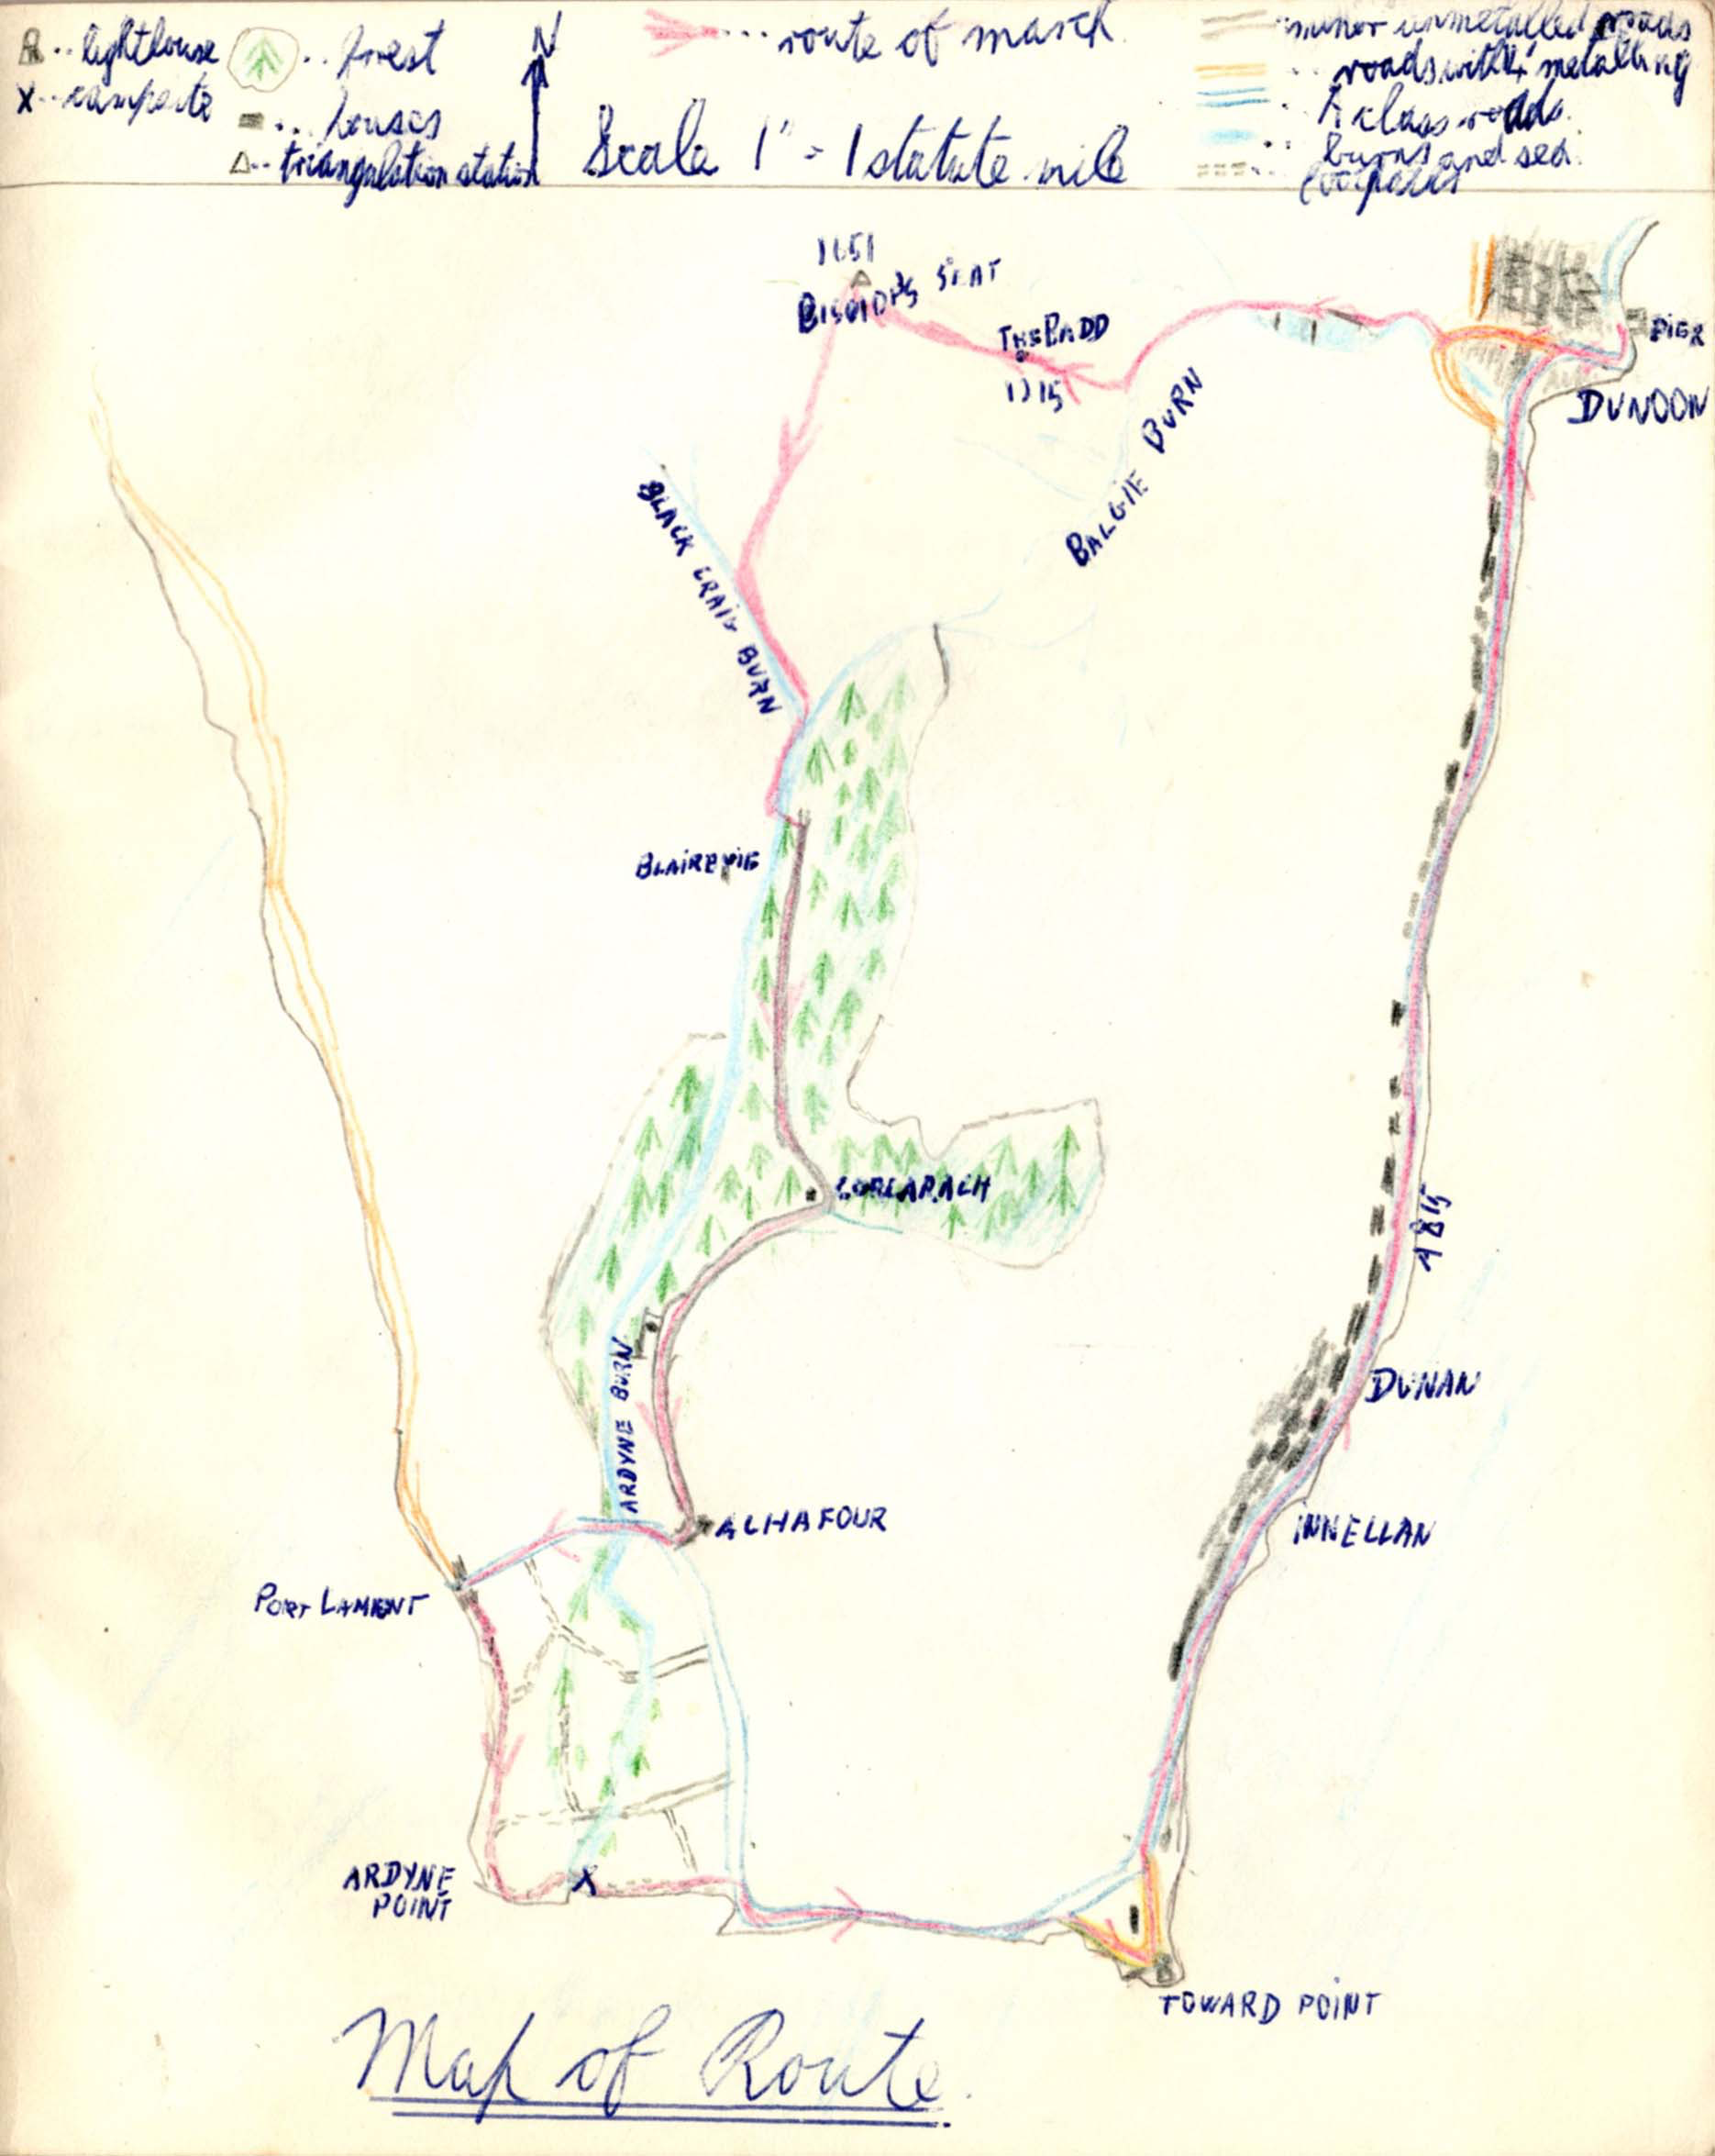

Page 4
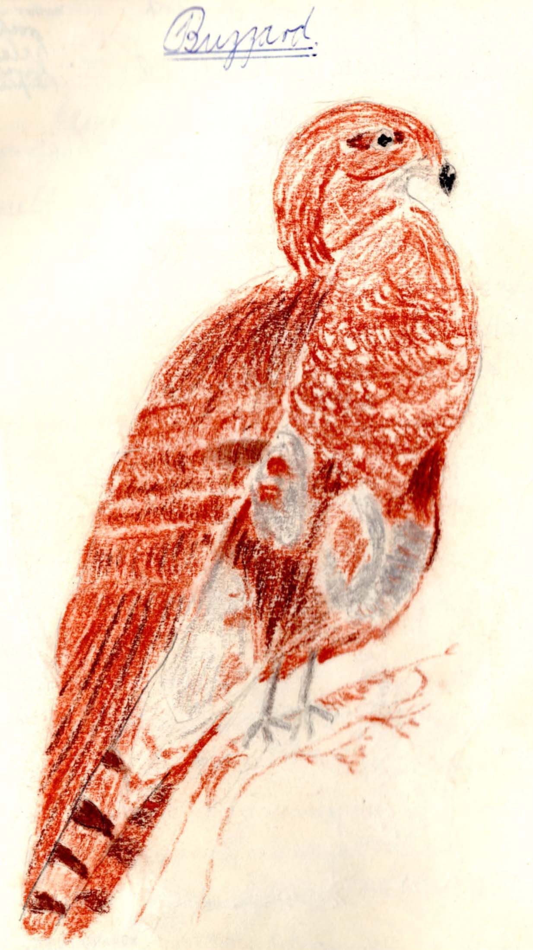

Page 5 Log

We left Dunoon at ten a.m. for Bishop’s seat (G. ref 132775) proceeding along a path past the three reservoirs behind Dunoon (10.50 AM). When the path came to an end (10.50 A.M., 1,1), we joined Balgie Burn hiking along it to the burn which runs up past the Badd 1,215 feet, G. ref. 139770 (11.50 A.M., 1, 2). From this vantage point, we observed a submarine sailing up the Clyde to the Gairloch, the Gantock’s light and the Cloch lighthouse. At that part of the hike, the weather was still good and the view up the Clyde was magnificent. After a 20 minute rest at the Badd (12.10 P.M.), we continued, observing a buzzard on the way to Bishop’s Seat which we reached at 1 PM (½, 2½).
On the summit of Bishops Seat, there is an ordnance survey triangulation station no. S5044. The view from Bishop’s Seat is also good though limited. Cotton plants abound in this area. While eating our lunch of sandwiches……
Page 6
.. and an apple, before proceeding, we saw a peewit. The wind at this exposed point was very strong blowing from the north. We tried to see the checkpoint at 1,875 feet on Cruach nan Capull but could not make it out.
After lunch (1.45 A.M.),we carried on to the Black Craig burn (2.15 pm), in which we noticed many brown trout some small others not so small. We followed the burn to its junction with Ardyne Burn at G. ref. 124748 (2.40 p.m.). We walked down Ardyne burn until a tributary joined it flowing in from Glen Fyne wood at G. ref. 123744. We took this tributary as our route until it joined with a Forestry Commission Road at 500 feet above sea level (3.00 pm, ½, 4¾).
The road, in our opinion, could not be used for the first stretch at least by motor vehicles. At every point where a burn crosses the track, there is a very boggy stretch for two or three yards and there are many more burns than are marked on the map. The wood also abounds…….
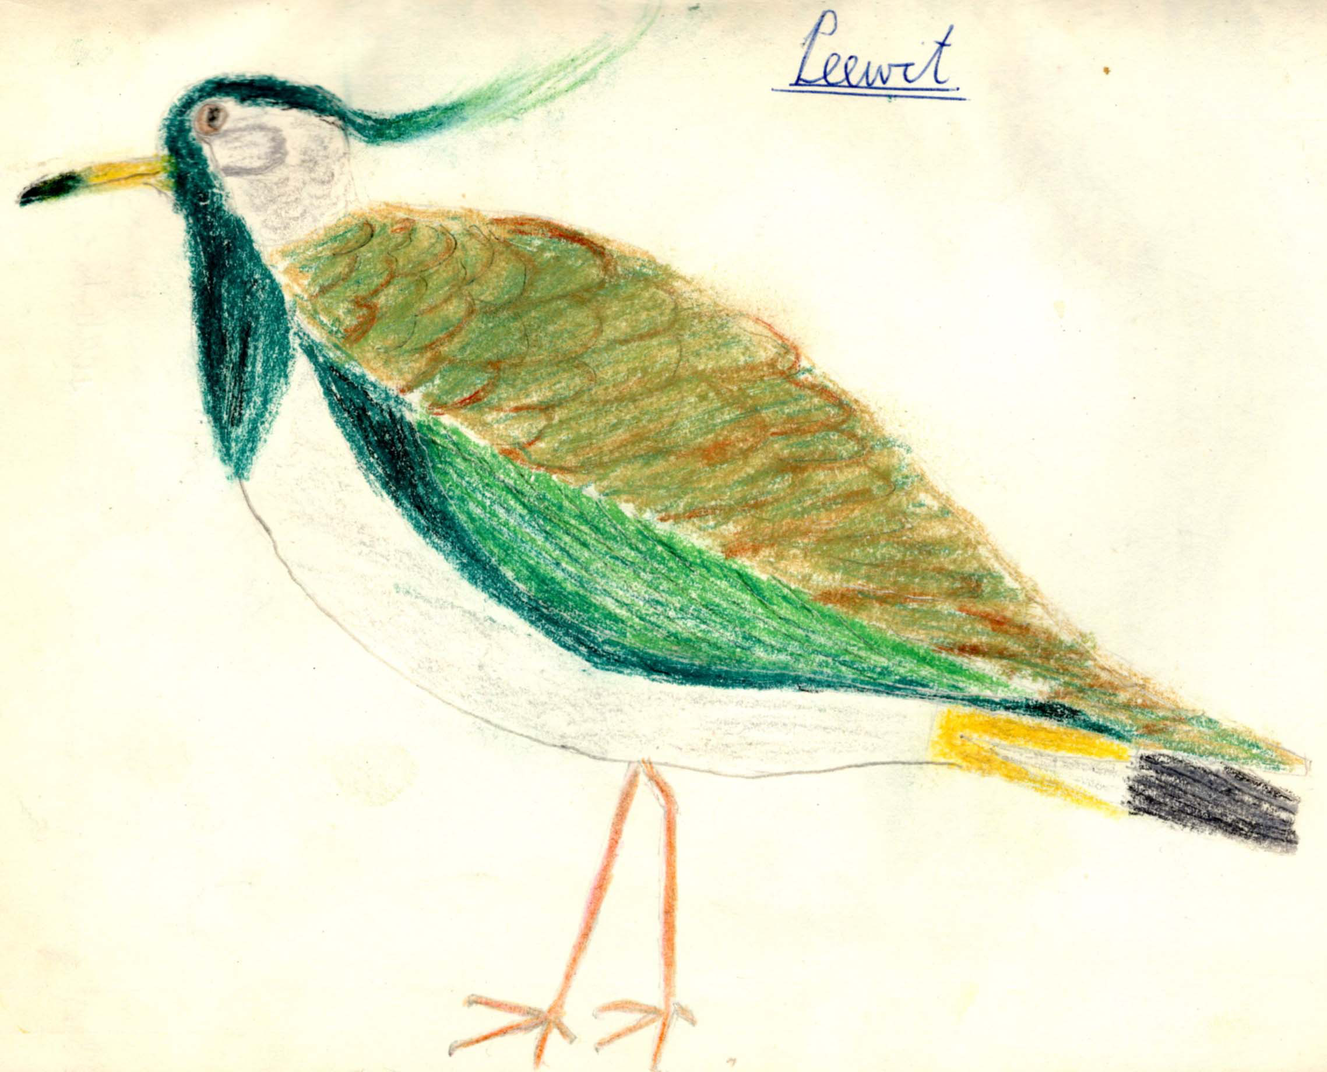 Page 7
Page 8

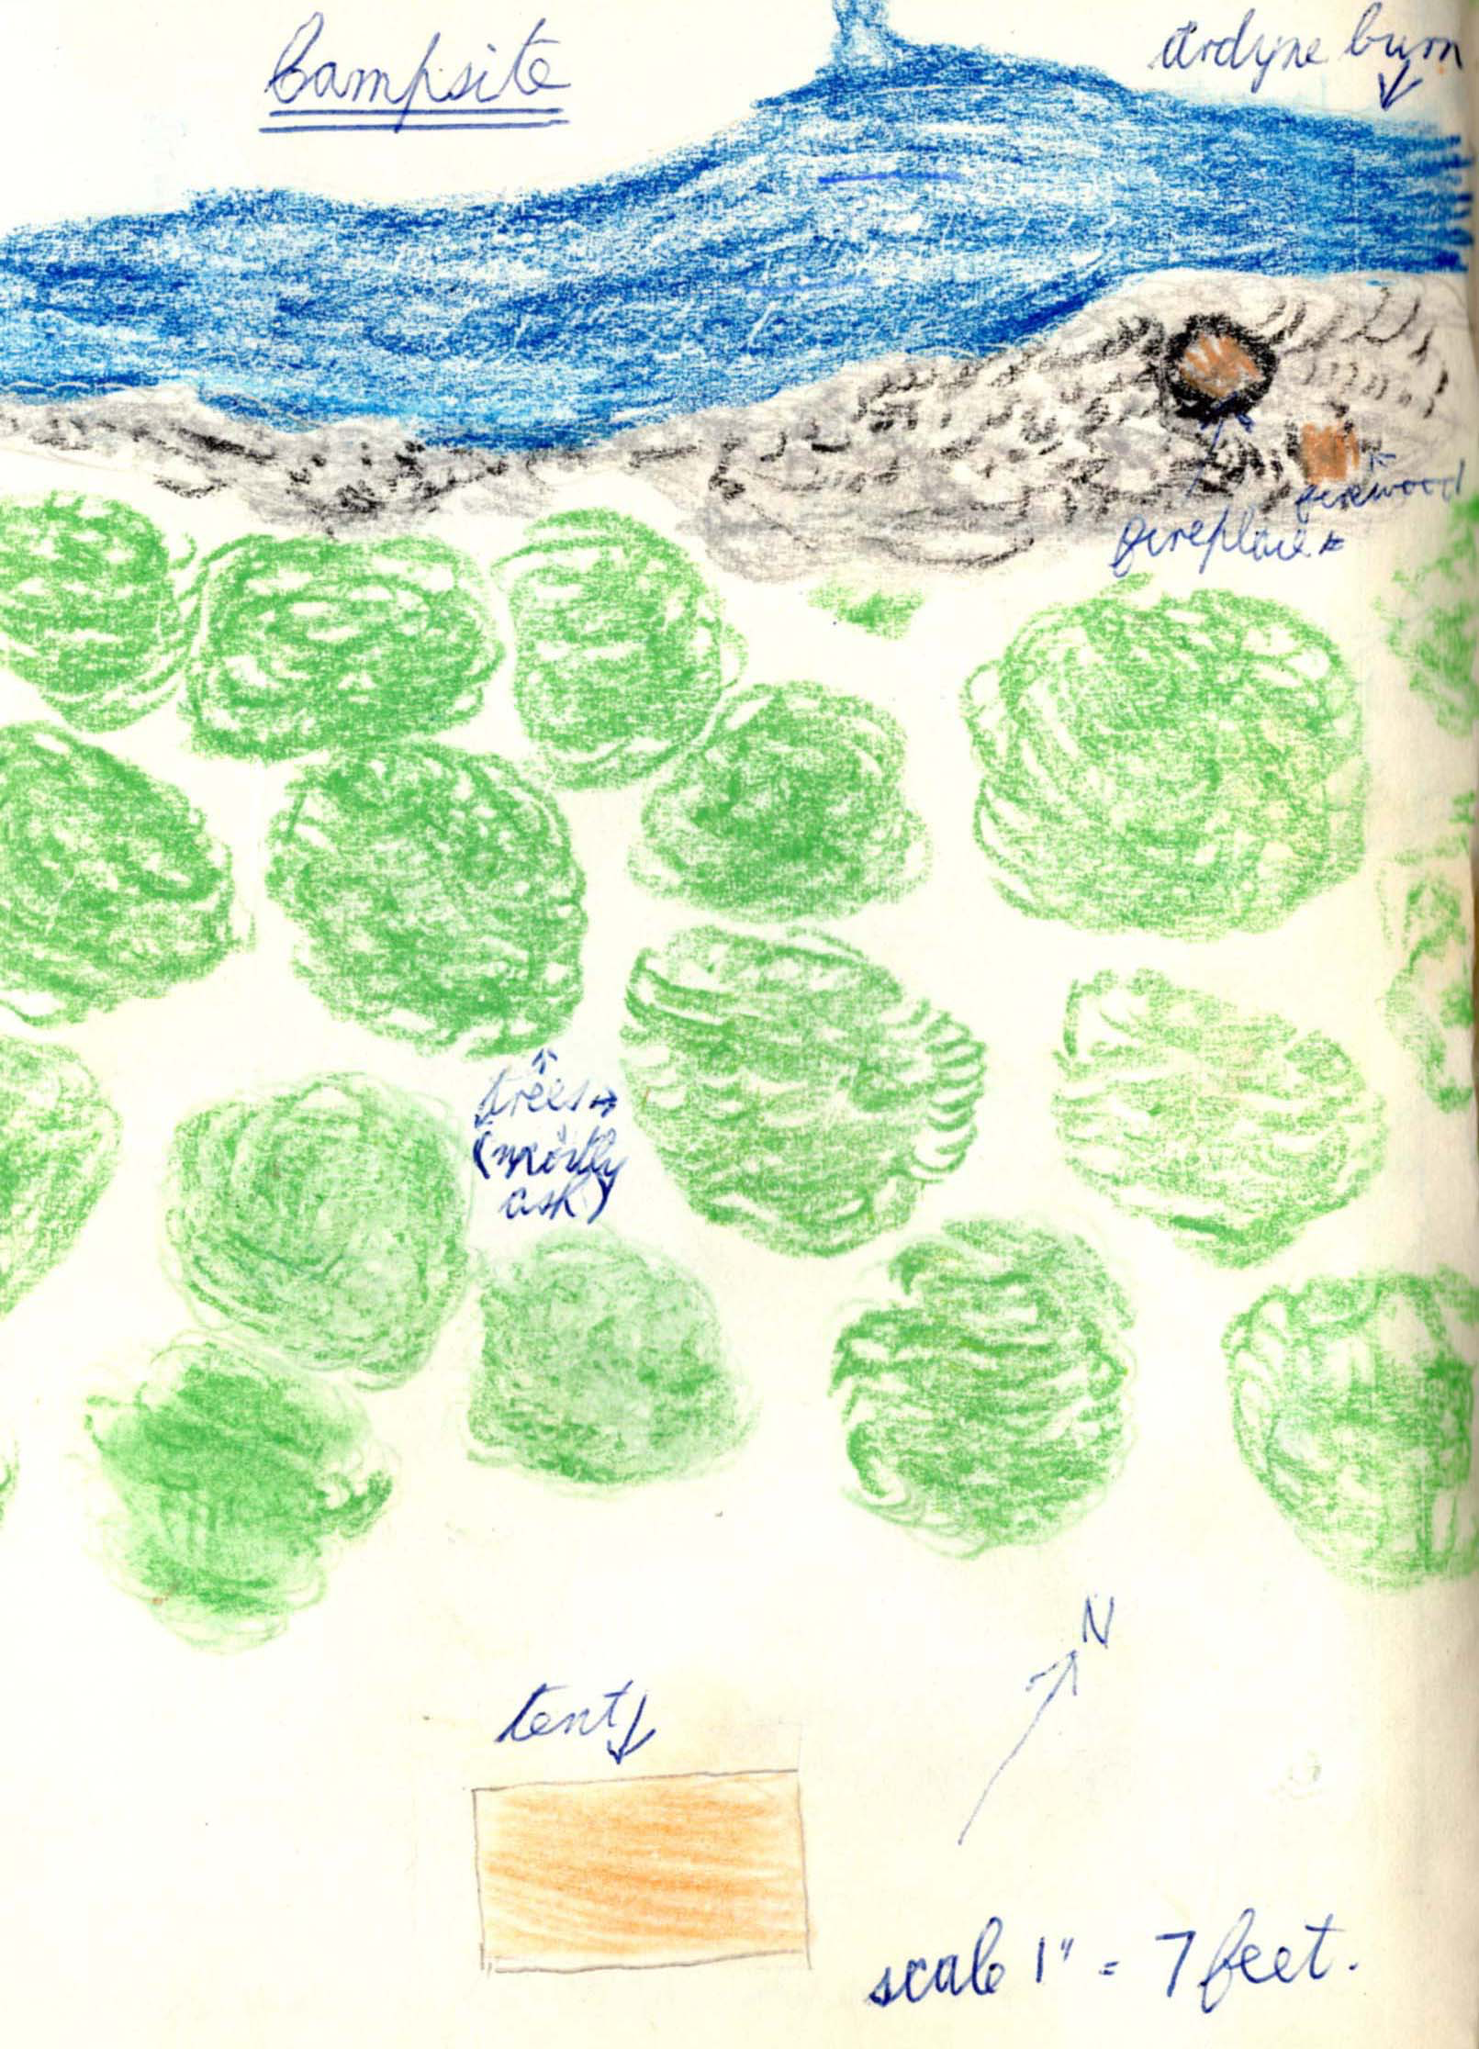

Page 9
.. with very large flies which I have not been able to identify. They were from two to three inches in length and at first sight looked like small birds. The road is also rather monotonous because one can naturally see nothing but trees and even flowers by the roadside are not plentiful. At 4:30, we reached Achafour farm and bought a pint of milk to refresh ourselves (3¼, 8).
On reaching the main road A815 (4.40 pm), we turned right and hiked on to Port Lamont (5 pm, 1, 9) which is a very small village with no shop but with a telephone kiosk. We took the shore road from Port Lamont following it down past Ardyne Point to Ardyne burn.
A small diversion at this part of the hike took us over some large heaps of sand which had been dumped for some reason that we could not discover. At the other side of the sand (6pm, 1½, 10½), we found an excellent camping…
Page 10
…. site near Ardyne Burn at G. ref. 103683. We immediately pitched the tent and got the foodstuffs out of our rucksacks. Between us and the burn there was a narrow sward of trees with plenty of dead wood about, so after gathering up firewood, we built a fire on the dried up half of the burn and cooked our tea which consisted of soup, sausages, beans, peaches with carnation milk, and coffee. After clearing up the kitchen site we rolled out our sleeping bags and had an early night (8.00pm). During the night we heard an owl hooting.

The next morning we rose at 8 AM and, after a wash, cooked our breakfast of cornflakes, bacon, beans and rolls. For the cornflakes we diluted down a small tin of carnation milk with water which had been previously boiled. We boiled all the water we took from the burn to make sure that it was pure. By removing a large stone from the dried up part of the burn we….

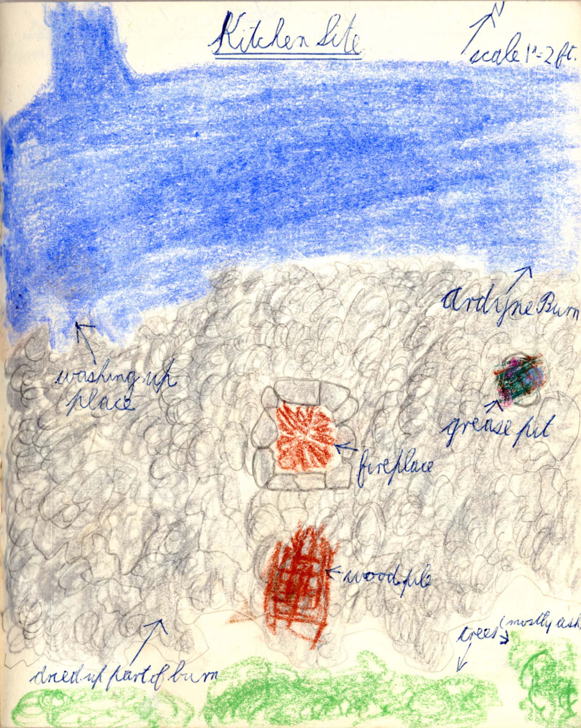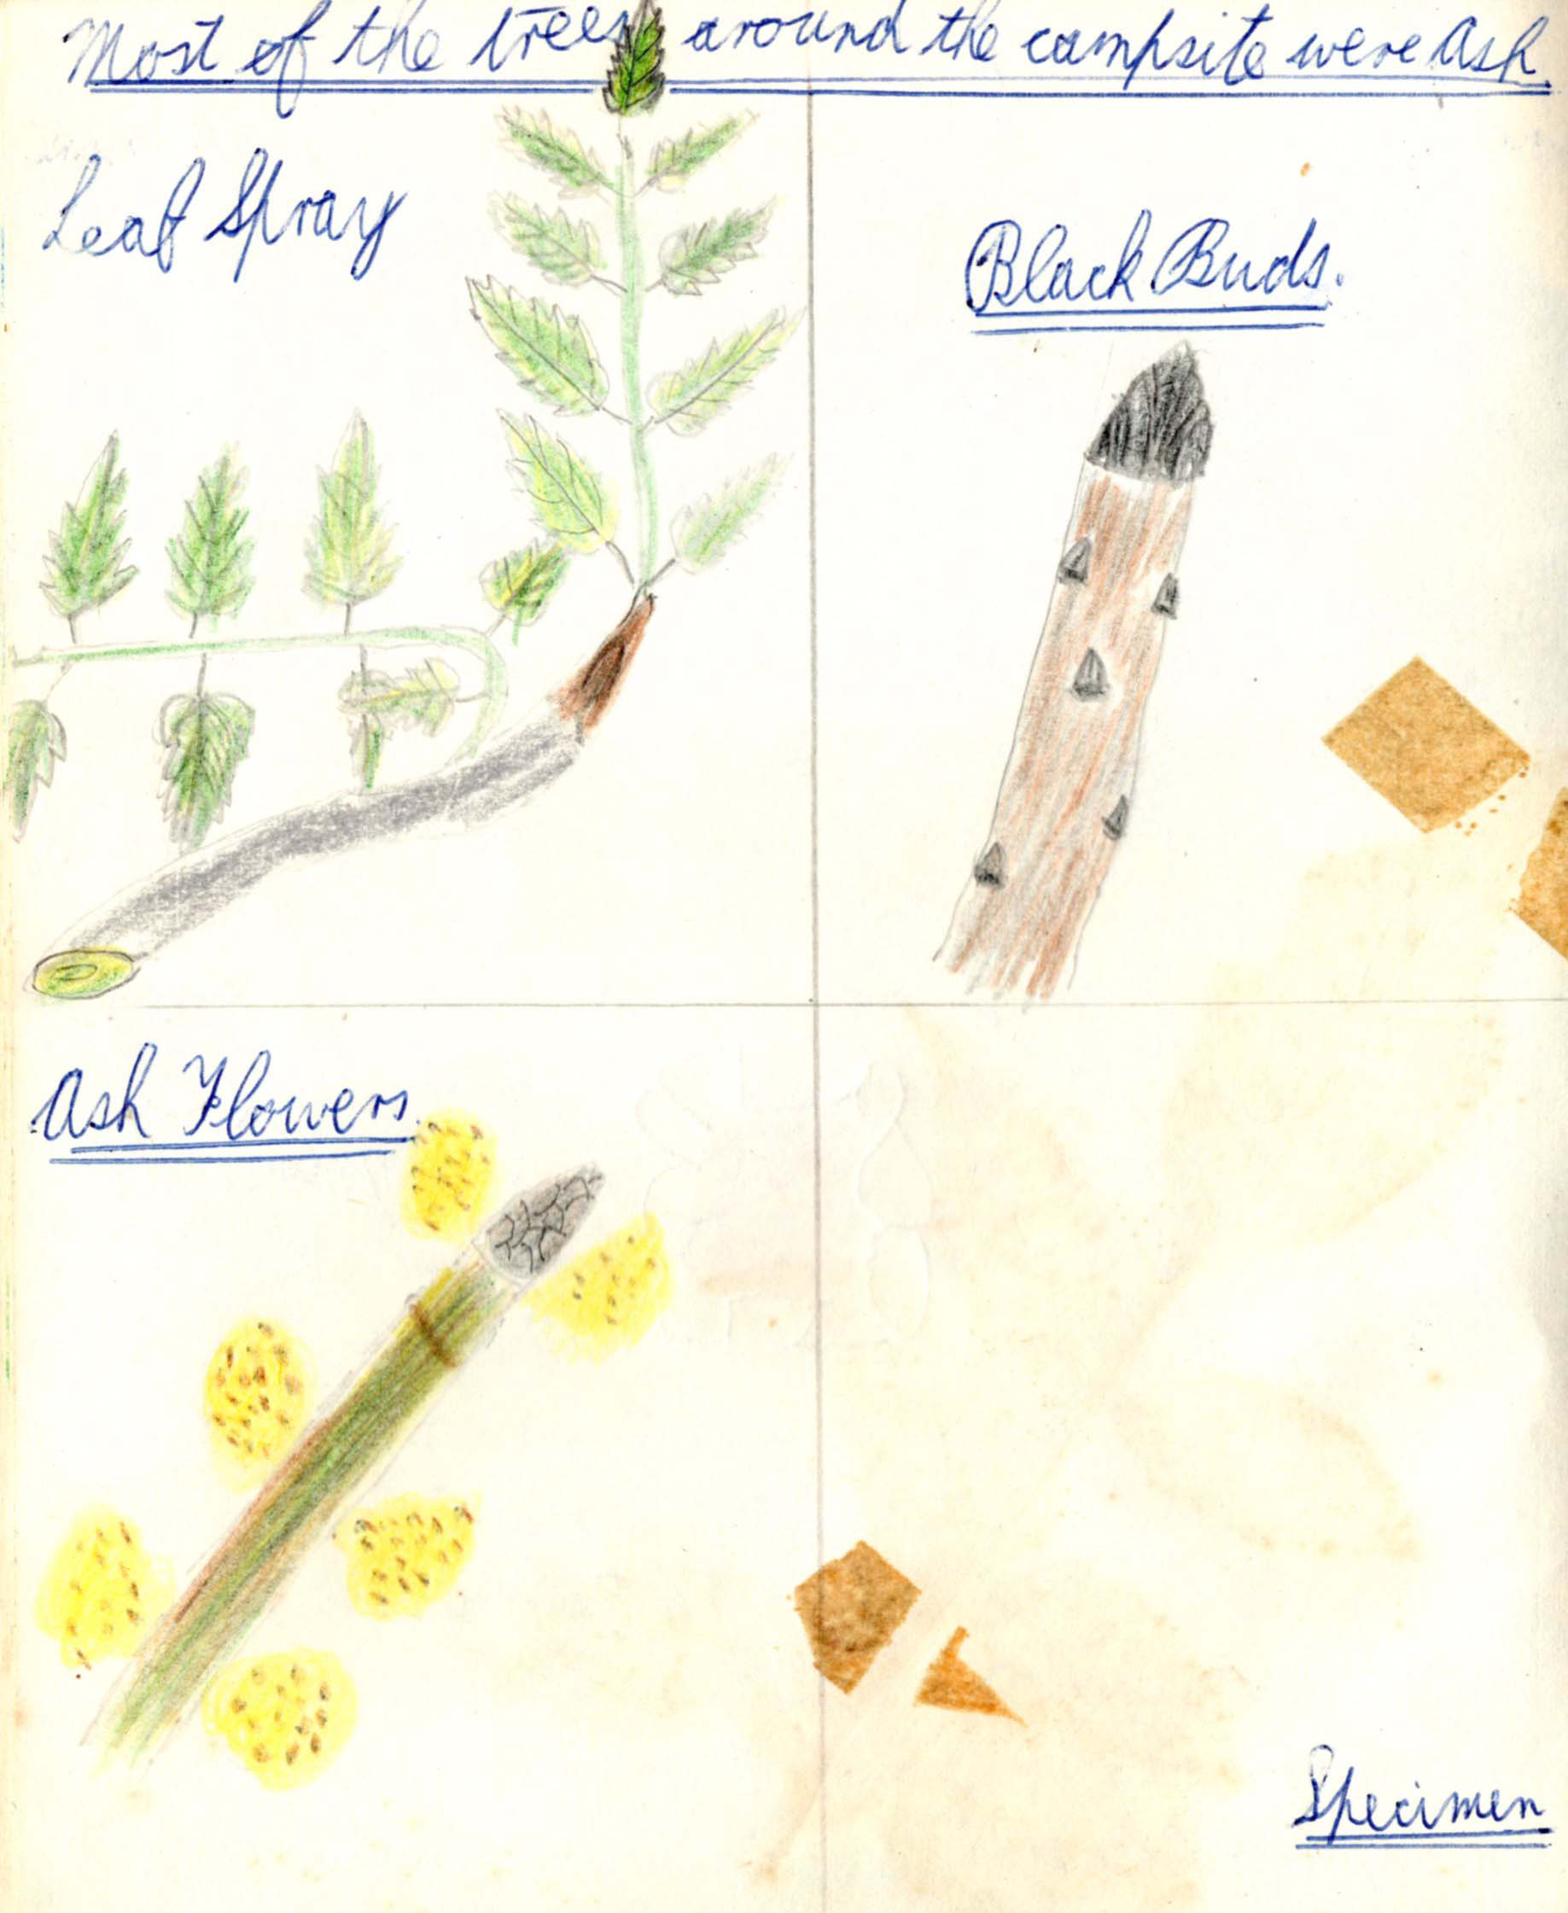
Page 11 Page 12

Page 13
… made a grease pit in which we buried all our old tins etc. After striking the tent and clearing up the kitchen site we carried on, leaving the campsite at 9:20 AM.
It had been cloudy when we woke up and it soon began to rain starting when we reached the main road again. Luckily it was only a shower and just lasted for one or two miles. On reaching G. ref. 130677 (10 am) we took the road round to Toward Point where we were each able to buy a bottle of lemonade (10.10am, 2¼, 12¾).
From the point we could see a destroyer anchored off Rothesay. There was a pier at Toward Point which was used regularly by the Caledonian steamers but it was demolished many years ago and only the approach to it and a few timbers are left. Despite an early bus service and a stretch of sand on the shore overlooking Rothesay Bay the small community here did not develop and has never grown…
Page 14
… much farther than the few houses it started out as.
Carrying on up the small road from Toward Point we rejoined the A815 at G. ref 136678 and taking along it at a steady if not very speedy rate of progress soon reached Innellen (10.50am, 2, 14¾). In the first place this was a settlement created by the well-to-do of Greenock. It consists mostly of villas built tier upon tier on a steep slope that has the slight disadvantage of cutting off the sunlight at an early hour of a summer evening. Innellen has benefited greatly from the coming of the motorbus because, due to its strip of real sand, it absorbs most of the overspill of visitors to Dunoon.
We left Innellen at 11 o’clock on the last leg of our journey and reached Dunoon at 12:55 (5¼, 20). On a hill to the westward side of Dunoon Pier faint traces of a castle can be seen. There is a legend that it was built by Dalriadie…..
Page 15
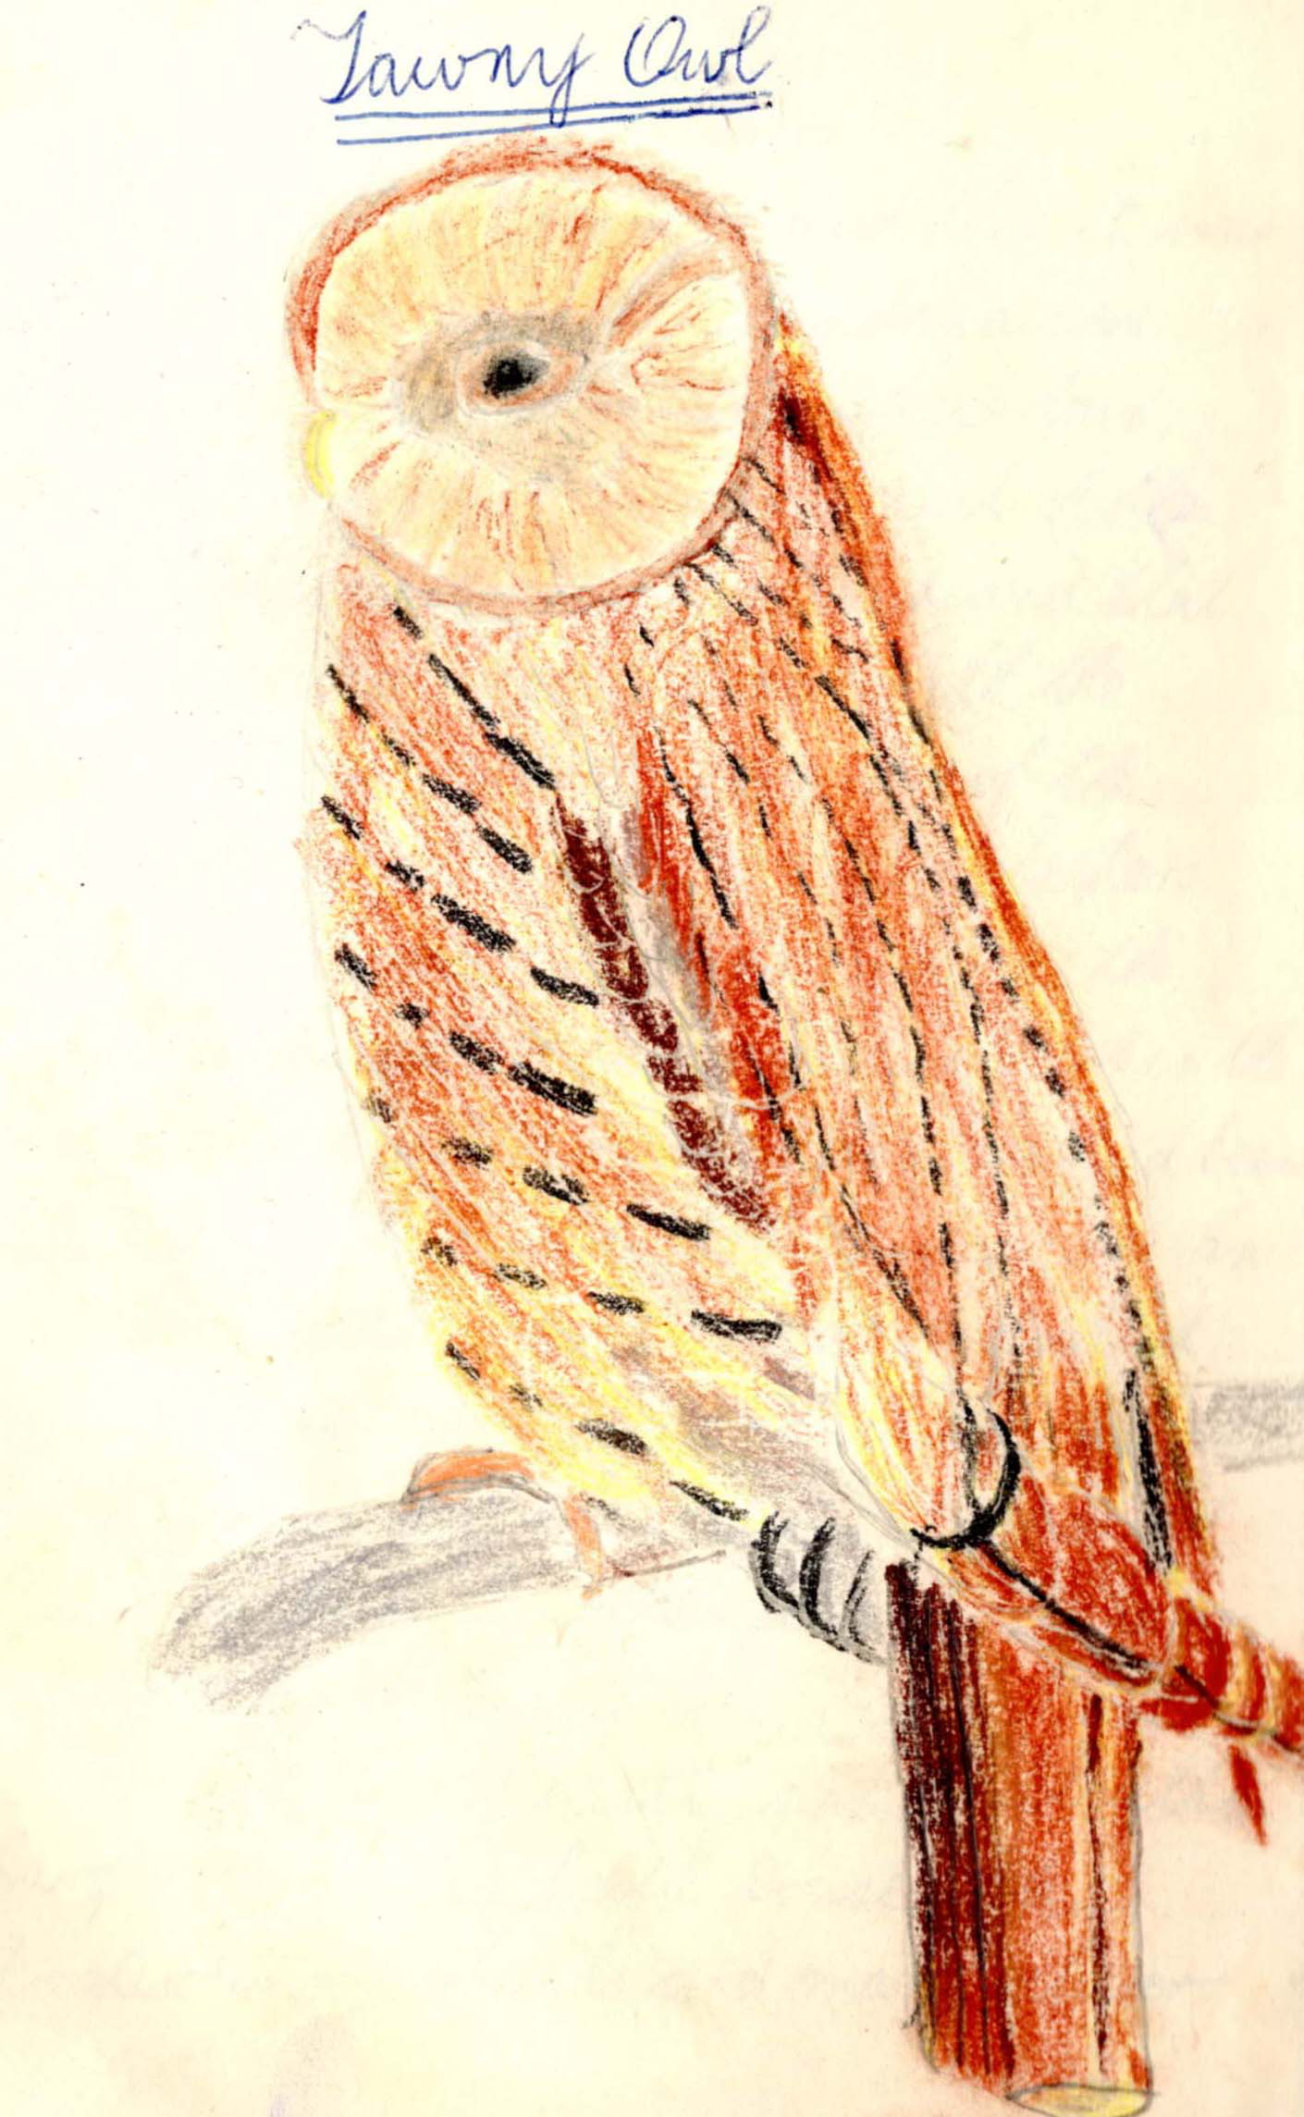
Page 16
…chieftains in the 6th century and that it was held for a time by the Scandinavian invaders. What is rather more certain, however, is that it became a seat of the Lord high stewards of Scotland and that it even was a royal palace with the Campbell’s of Lochaw, ancestors of the Dukes of Argyll, as its hereditary keepers. After the massacre of Dunoon in 1643 the Campbells ceased to have much interest in the Castle and by 1822 much of its stone had been taken away to build cottages piers etc. In the same year Dunoon also dwindled until it was only a clachan.
The coming of the steamboat saved Dunoon. In that same year of decline a certain James Ewing took out a feu near the site of the old castle and built a large vila called Castle House. The prosperous merchants and manufacturers….

Page 17
…. of Glasgow soon followed his example and the hamlet expanded into a small town. The Steamers kept pouring the masses into Dunoon and in due course the wealthy withdrew to more westerly positions. Dunoon is now a thriving holiday resort and the villas of the old Glasgow merchants have mostly been changed into boarding houses.
Robert Crawford
(70th Renfrewshire)

Page 18 Blank
Page 19

Menu

Lunch on Wednesday:- sandwiches and apples
Tea on Wednesday:- soup, sausages, beans, peaches and cream, coffee.
Breakfast on Thursday:- cornflakes, bacon, beans, rolls.

Strip Map
