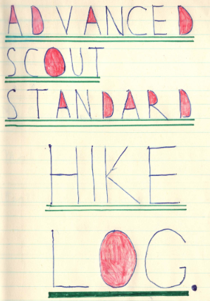

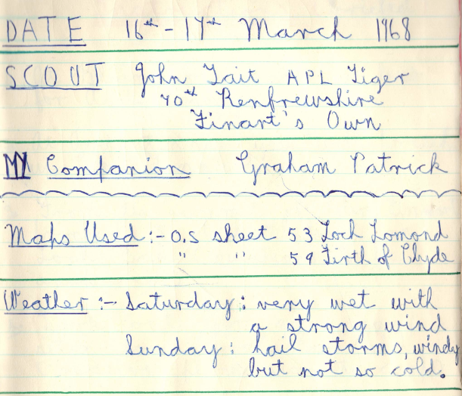
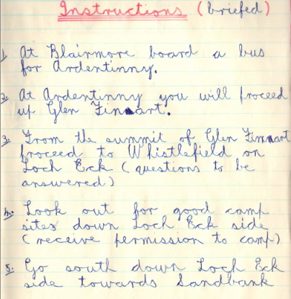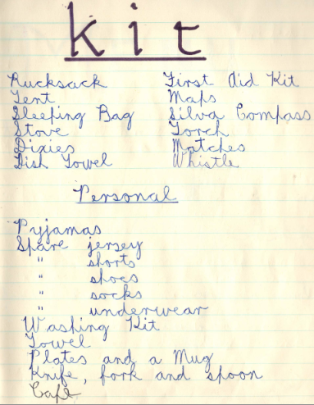

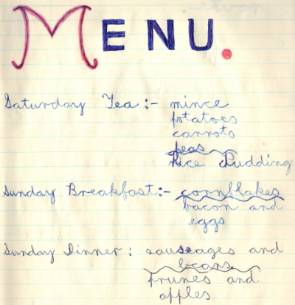

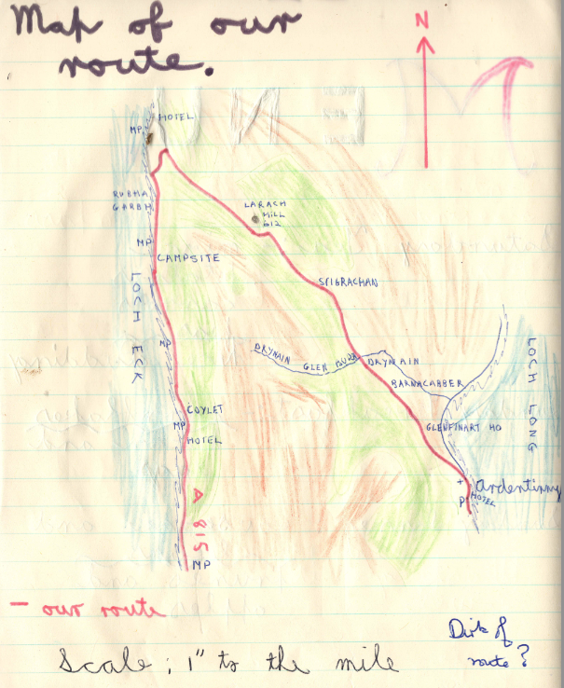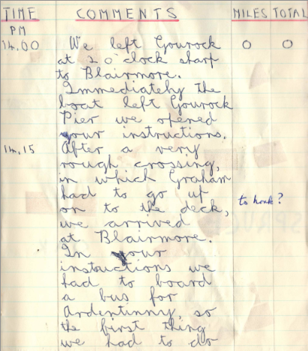

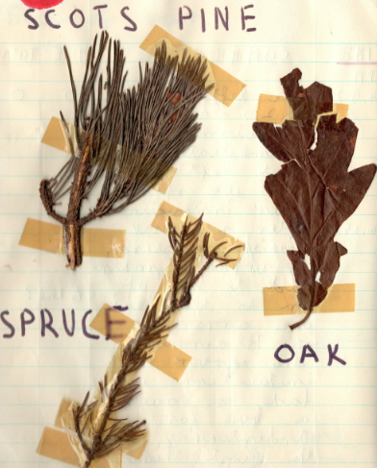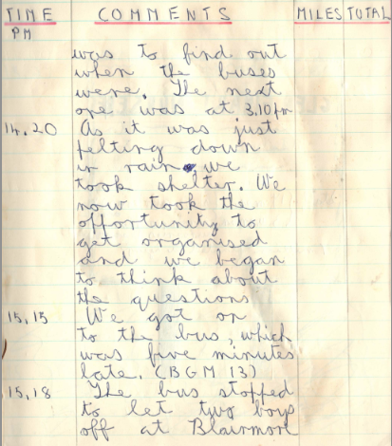

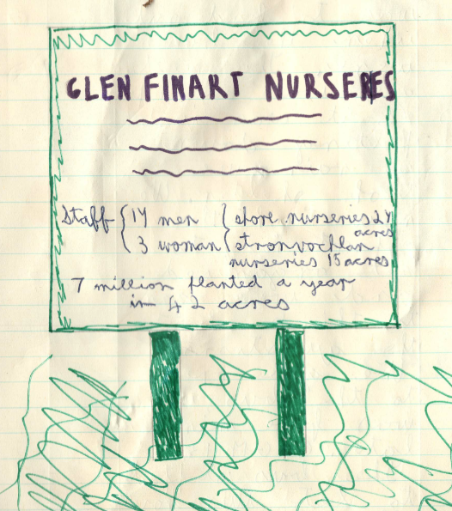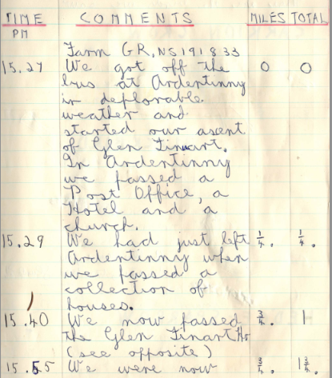

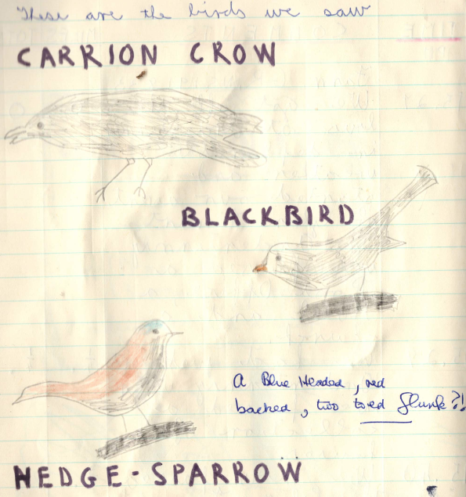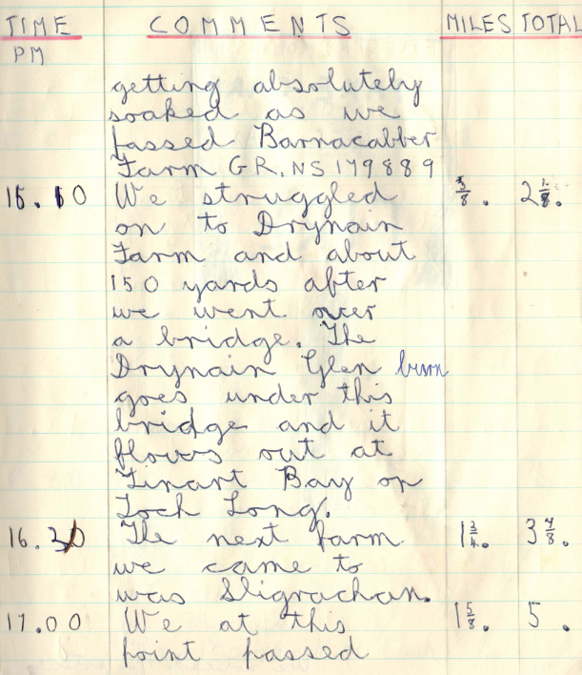

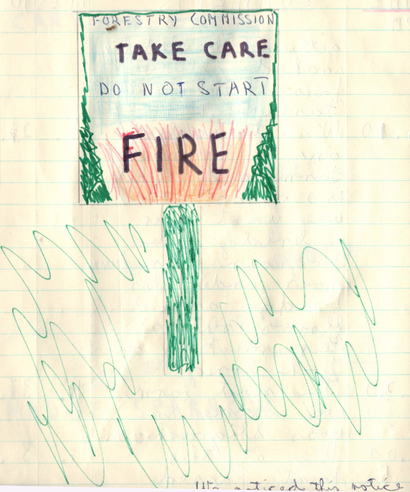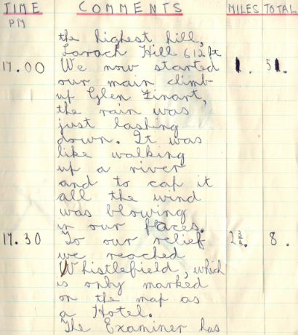

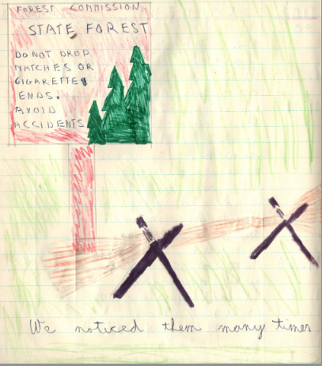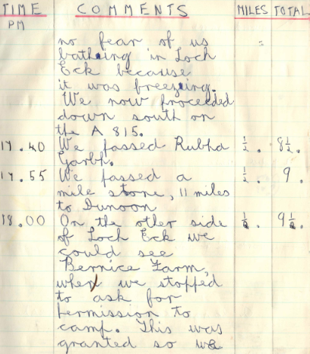

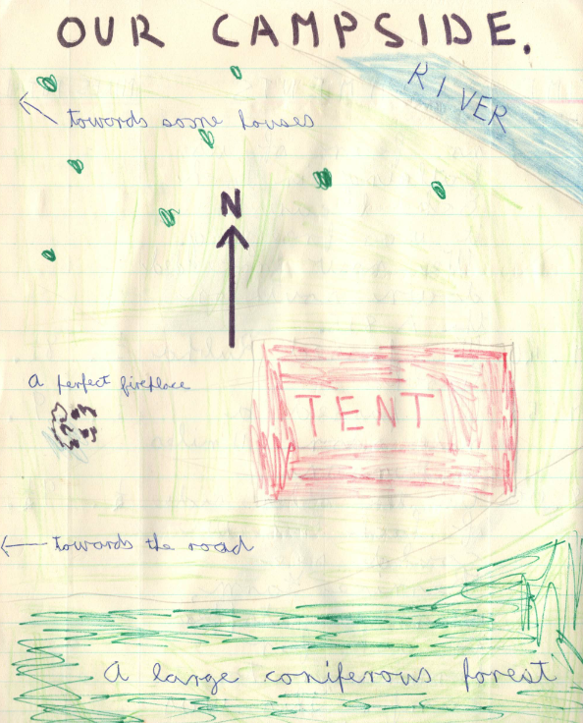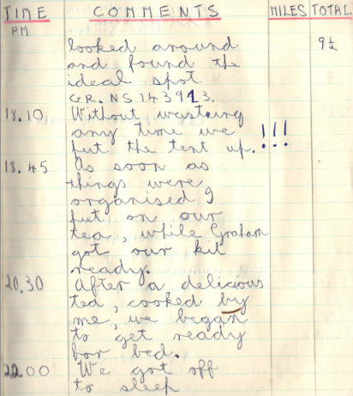

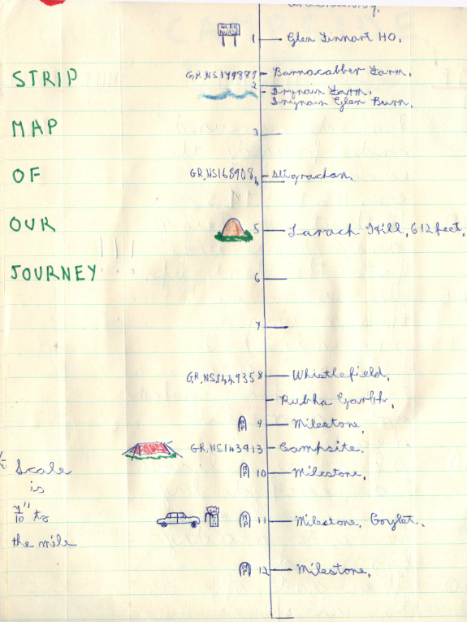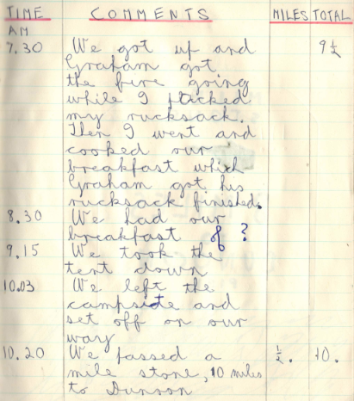

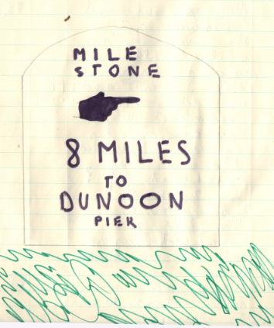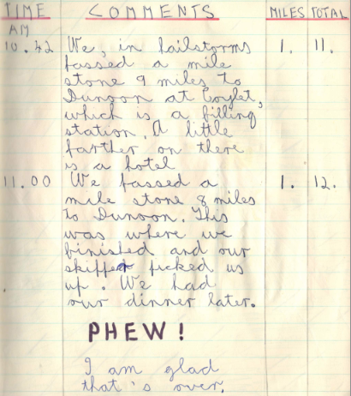

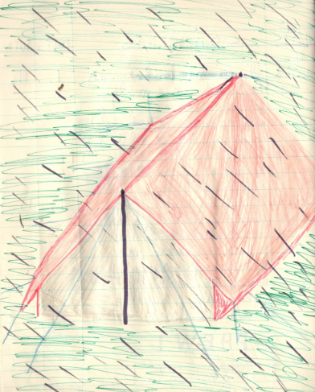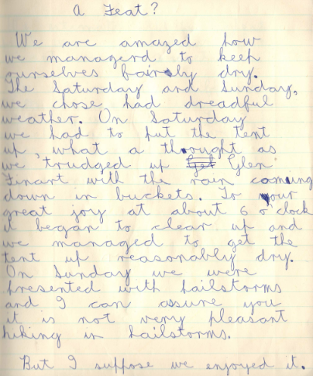

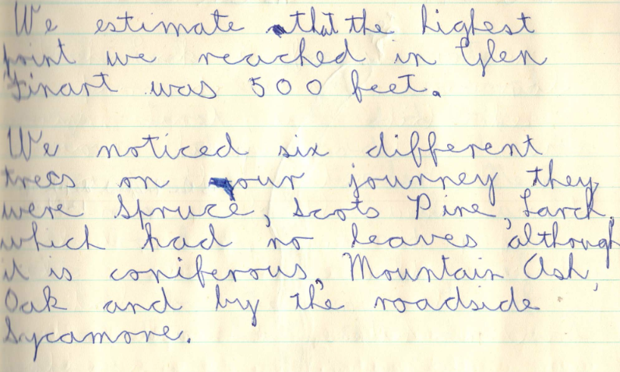

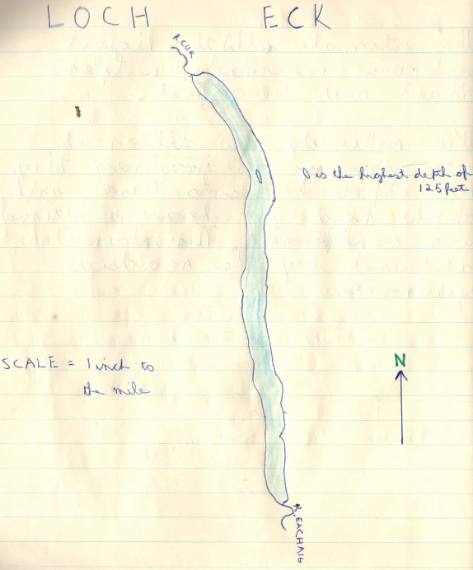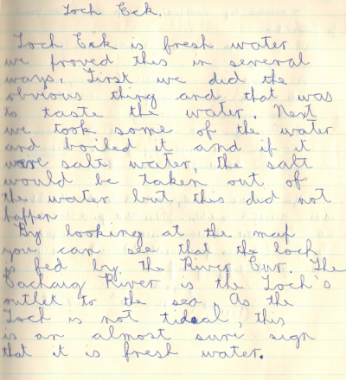

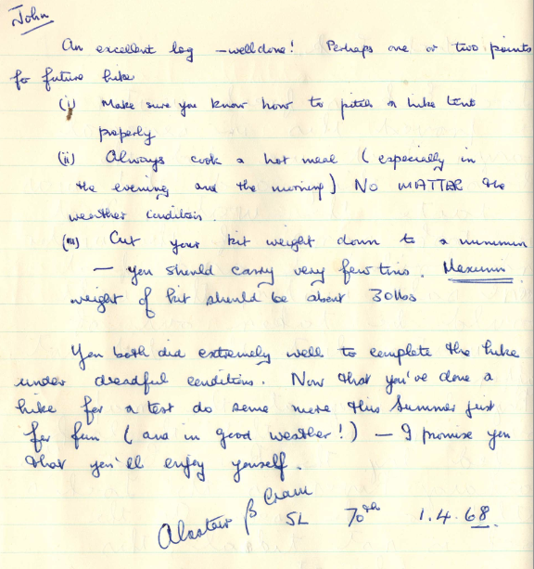

Additional Comments from Graham Patrick

This was the first Advanced Scout Standard hike carried out in the 70th following the introduction of the new training scheme in 1966. Therefore, it was very similar in nature to the previous First Class hikes. For example, there were only two of us on the hike and we both hiked in full uniform (including kilts). The hike was unsupervised and we had to make our own way by ferry and bus to the starting point at Ardentinny. What we did not appreciate at the time was that Alistair Cram and Robin Crawford had brought a car over and were shadowing us. We did spot a car behind us when we were heading into Glen Finart and we thought it odd that it stopped, but we did not cotton on to the fact that we were being shadowed in this way, and we got the shock of our lives when Alastair and Robin appeared out of the blue at our campsite on the Saturday evening to find out how we were doing. It has not been established whether this supervision at a distance was typical of previous First Class hikes. I suspect not. In this case, the hike was being carried out at an unusual time of year and the weather was particularly poor. We were also quite young. John was 13 and I had just turned 14. Therefore, the remote supervision made sense and was probably a factor in our parents allowing us to carry out the hike. I recall that I had been pestering people to do the hike and had originally wanted to go on the hike during February so I could complete my ASS before I turned 14.
The hike route was much the same, if not identical, to previous first class hikes and we were expected to find our own campsite. We ended up asking for permission at one of two forestry commission houses on the left hand side of the road, about a mile south from Whistlefield. The lady of the house said that we could camp behind the house, but I cannot recall whether it was in open ground or was part of the back garden.
The style and standard of hike log expected for this hike was the same as for the previous First Class Hike and had to include information on tasks that had been set. For example, one such task was to determine whether Loch Eck was a salt water or fresh water loch and to identify different ways by which that could be determined.
I remember being quite pessimistic about passing the hike once it was over – something that we would not find out until we had completed the hike log which took about a week or two. There were several reasons for this which John has carefully omitted from the hike log.
- When we tried to put up our tent we were dismayed to find that it was only about a couple of feet off the ground. I suppose at the time that we assumed that some of the poles were missing. It was just as well that Alistair and Robin turned up and told us that the missing poles were actually inside the poles we had used to pitch the tent. Hence the comment at the end of the log report on making sure that we knew how to pitch a hike tent properly.
- Before Alistair and Robin turned up, we may well have been rather downhearted at not our attempts at pitching the tent, as the lady in the nearby house suggested that we cook our meal in her kitchen. We were initially reluctant to do this and had a long discussion about it, but I suppose the weather had also got us down as we eventually accepted her offer. However, we still insisted on using the primus stove rather than the lady’s cooker. We were half way through making our meal when Alistair and Robin appeared at our tent which was visible from the kitchen window. We both felt sure that we would be failed for not cooking outside.
- On the Sunday, we had completed a total of 12 miles when we found Alistair and Robin waiting for us. They then drove us to Dunoon pier. However, our instructions seemed to imply that we should walk all the way into Sandbank. In hindsight, I suppose that Alistair and Robin felt that 12 miles was more than sufficient for two bedraggled young Scouts in the rain and the hail. At the time, however, we felt that we had not completed the hike and so we would not be passed.
- Alistair and Robin must have dropped us off at the ferry, because I remember that the two of us were waiting at the bus stop in Gourock for a bus back home. A car drew up and the driver offered us a lift, which we accepted. I can’t remember whether we both agreed or whether it was John, because once we were dropped off at Wood Street, he told me that the driver had been the District Commissioner J.J. Swan. One of our instructions during the hike was that we would be failed if accepted a lift. I must have assumed that this included the journey to and from the hike because I immediately assumed that the DC would tell our Scout Leader and we would be failed.

In the end, we both passed as stated in John’s log. Alistair Cram encouraged us to carry out more hikes in good weather and promised that we’d enjoy ourselves. I’m not sure that either of us were all that convinced about that at the time. However, Alastair’s promise was accurate and we went hiked a lot together in the years to come, including the hikes involved in the Duke of Edinburgh scheme.

It is interesting to compare equipment in 1968 with what is available now. Camping and hiking equipment in 1968 was pretty rudimentary. Our tent was a Clan tent, designed and made by the Clan Tent Company owned by David Chalmers. It was one of the first examples of an affordable light weight tent. However, it did not have a sewn in groundsheet (which had to be carried separately) and there was no flysheet, so it was important to avoid touching the tent one inside. The standard stove at the time was the primus stove. This was very effective, but it required skill to light it safely as it had to be pre heated with meths. If it was not properly preheated, the paraffin fuel would come out as jet of liquid and create a flamethrower effect. Hence, their use inside tents was utterly forbidden for Scouts. However, using them outside in a wind was difficult and it was essential to find a sheltered position if it was to be used effectively. Gas stoves did exist at the time, but they were far too weak to be effective in outdoor conditions. Small personal sold fuel stoves were also available, but not very practical for Scout hikes. When Trangias eventually appeared on the market, the use of primuses generally stopped as far as Scouts were concerned. The maps used were not metric yet and the standard map was the 1 inch to a mile scale.
As far as personal clothing was concerned, there was nothing really available on the market. In 1968, there was no breathable waterproof clothing available, and on this hike, we used bicycle capes as waterproofs. These did have the advantage that you could wear the cape such that it also covered the top of the rucsac and helped keep the contents of the rucsac dry. The rucsacs themselves were old style commando like rucsacs without waist belts. Thus the weight was mostly on the shoulders. Moreover, the rucsac material was not waterproof.

The nature of the ASS hike changed significantly over the following years, partly driven by improved clothing and equipment, the Duke of Edinburgh scheme, increased private transport and an greater focus on adventurous activities within the Scout Training Scheme. Hike routes became a bit more varied and moved away from roads onto paths and trails. This was partly due to increasing traffic on the roads, but also due to raised expectations in finding more adventurous routes where more use of the map and compass was required. The idea of Scouts hiking in pairs and in full scout uniform was dropped relatively quickly. Before long, the standard approach was to have at 4 scouts hiking together with two hike tents, wearing outdoor clothing. Cooking over wood fires disappeared pretty quickly and cooking was carried out over primus stoves (or trangia stoves when they appeared on the market). The requirement to complete a full hike log (similar to the one shown here) carried on for several years, but eventually it was found that an increasing number of Scouts failed their ASS hike because they never got around to completing the log. Eventually, the idea of writing a log was replaced with giving a talk on the hike. Readers may well have their own opinions as to whether this was a good thing or not. As far as supervision was concerned, Scouts continued to hike without direct supervision, but leaders made a point of checking up on the group at their campsite to ensure that they were on course, as well as checking that they had completed the hike.

The Advanced Scout Standard was eventually replaced by the Explorer Award in 1984, but the progressive Scout training scheme was dropped altogether following the milleniusm. Again, readers are likely to have their own opinion on whether this was a good idea or not.

