**15th to 16th June 1957 Shannon Cup competition**1

The Shannon Cup team2 was as follows:-

J. Harvey 3 (PL)11

A. Shearer4 (Second)11

H. Rankin5 - 1st Scout11

J. Nisbet6 - 2nd Scout11

B. Elliott7 - 3rd Scout11

A. Campbell8 - 4th Scout11

A. Nicol9 - 5th Scout11

J. Blair10 - 6th Scout11

**Saturday 15th June 1957**

The Patrol met at 12:45 p.m. at George Square to get the 1 p.m. bus to Inverkip12. Bus after bus passed and B. Elliotte went to phone home for “Dad to bring his old bit bus” to take them to Inverkip13. This (phone) was done against the P.L.’s orders!!! The other four (A. Shearer had gone on alone) went to Hunter Place to get the bus which left at 1:50 p.m. (approx.). The other three were seen at George Square with “Dad’s bus” but the misunderstanding was settled at Inverkip. The Patrol arrived at Everton with their kits and other gear14 about 2:30 p.m. and, at 3.00 p.m., there was an inspection by the examiners.

Camp was then made, the “Niger” being pitched without the main guy ropes15. The Patrol then changed and the examiners came round to inspect the site briefly. Wood was then chopped for gadgets as well as for firewood, and the fire was lit, for the tea was to be made by 5.00 p.m. when the examiner came to see what it was like. Tea? – pies and beans ( cooked by the P.L.) + bread, jam and camp ‘tea’.

After tea, two blasts on a whistle sent the PLs of the 32nd, 45th and 70th (competing troops) over to the 5th hut.16 They were to collect 8 trees17 and 10 flowers and make a list of all birds and animals likely to be seen in the wood.

There was then a trail to be followed18 and at the end of it a boy was sitting with a scalded hand (due to careless handling of a spirit stove).19 The hand was bandaged and the ‘patient’ was put on an improvised stretcher.20

Games followed (mostly relay races).

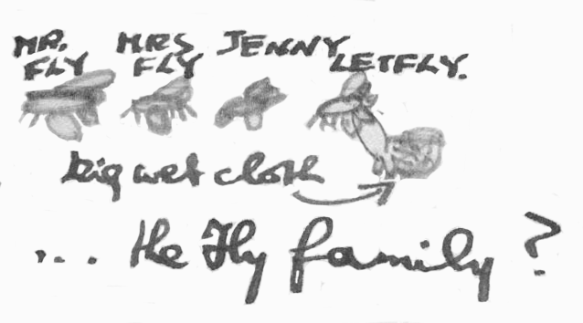The Teams were then free until campfire for which wood had to be fetched.

At the campfire, each patrol did a stunt. The stunt *that the* 70th did *was* the “Fly family”’ (see sketch).21

The Patrols then turned in but no one got much sleep that night, not only because of the heat, but *also* because of the “wee beasties” (midges etc).

**Sunday 16th of June 1957**

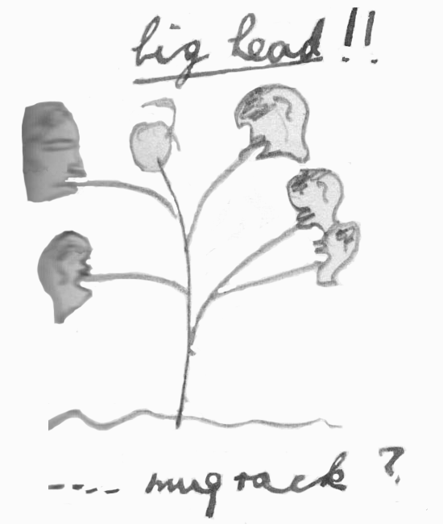We rose at 8 a.m. and had breakfast (cornflakes, ham & egg, bread, jam, tea) ready by 9.00 a.m. for the examiners’ inspection.

The Patrol went on with camp gadgets22. The ones we made were towel rack; mug rack, cutlery rack, plate rack, table, basin stand.

At 11.00 a.m. a.m. came the Scouts Own23 at which all three PLs read.24

After that, the Patrol (four actually –four stayed to cook the dinner) went outside the camp to take compass bearings of four points viz:-

Toward Point

The Gantocks,

Quarry at Innellan,

Dunrod Hill.

Dinner was ready by 1 PM, which was fried sausage, potatoes and peas with two big tins of peaches for pudding.

There was an inspection at 2.00 p.m. and some boys went up to the pool25 for a quick swim.

The Patrol was sent on a mission to find a band of lost explorers. We were given one clue. The course was S.S.E.26 of the water tank along the bed of a river. The ‘explorers’ (boys roped in from other troops) were taken back to camp when the necessary first aid had been applied. A few minutes later, the whistle took J. Harvey across to the hut to get more instructions: – ‘find a good turn or make a model of a bridge in half-an-hour’. The job was completed a few minutes after the allotted time.

Tea was then started, the last meal of the camp, and was salad with fried potatoes, bread, jam and tea. Two of the examiners sampled the fried potatoes.

While the dishes were done, the campsite was cleared up and then the kits were put away, and uniform put on. There was a final inspection at 6.00 p.m.

At 6.30 p.m., the three patrols assembled outside the hut27 waiting in suspense for the result.

Mr “Bertie Morrison”28 took the piece of paper and handed to him and read out the result

RESULT:-

1st 32nd Renfrewshire with 149 points out of a maximum of 185

2nd 70th Renfrewshire - 141 points

3rd 45th Renfrewshire - 122 points

To quote Bertie’s words “So ends another Shannon Cup competition.”

John R. Blake29

*Editorial notes for 15th-16th June 1957*

1. *The Shannon Cup Competition was the premiere District camping competition during the period from the 1930s to the 1960s. It was also the most prestigious of the various District Competitions and the 70th usually entered a team if it could.*

2. *Each patrol could have a maximum of 8 Scouts and the rules regarding the Scouts chosen may well have varied over the years. In 1957, older Scouts who had resigned as PLs to join the leader team could be part of the team, and more than one existing PL could also be in the team. The make up of the 70th’s team in 1957 suggests that there might have been a rule stating that each patrol could include 4 younger, non-promoted Scouts.*

3. *JASM* *Jim Harvey was aged about 17 at the time. He had been PL of the Kingfisher Patrol until October 1956, then joined the Scouter team as a Junior ASM. He gained his 1st Class Badge, but it is not known whether he gained the Queen’s Scout Badge. It is probable that he did, but that needs to be confirmed.*

4. *JASM* *Alastair Shearer was aged 17 about at the time. He was promoted to P.L. in mid 1955, but it is not known of which Patrol. By January 1957, he had resigned as P.L. to join the Scouters team as a Junior ASM. Alastair had completed his Queen’s Scout Badge by the time of the Shannon Cup Competition and had been chosen as one of the 70th’s representatives at the forthcoming World Jamboree in the summer.*

5. *P.L. Hamish Rankin of the Falcon Patrol was probably aged about 14 at the time and was P.L. of the Falcon for about 4 years. He had been a member of the 70th Patrol that had won the Shannon Cup the previous year. Unfortunately, there are no records to show how far through the Scout Training Scheme he got*

6. *P.L. John Nisbet of the Fox patrol was aged about 14 at the time and was working towards his 1st Class Badge in June 1957. He was PL of the Fox Patrol for 3 years.*

7. *P.L.* *Brian Elliott of the Curlew Patrol was aged about 13 at the time and had been promoted the previous February. He may well have gained his 2nd Class Badge by June 1957.*

8. *Alasdair Campbell was unpromoted at the time, but it is not known which Patrol he was in or what age he was in June 1957. Very little is known about him, other than he was promoted to Second in 1958.*

9. *Alastair Nicol of the Patrol was probably aged about 14 at the time, and was Second of the Falcon Patrol. He had gained his 2nd Class badge by June 195y, bu little else is known about him*

10. *Jim Blair of the Patrol was probably the youngest member of the Patrol and would have been aged about 13 at the time. Nevertheless, he had gained promotion by this stage and was Second of the Kingfisher Patrol*

11. *The ranking shown here were purely for the 70th’s Shannon Cup Patrol*

12. *Relatively few people owned cars in 1957 and so the majority of people relied on public transport to get anywhere.*

13. *Very little is known about Brian Elliott’s family background. However, this might suggest that Mr. Elliott ran a bus of some sort.*

14. *It’s not clear how the camping gear (e.g. the Niger) was transported.*

15. *It’s not known whether this was deliberate or not.*

16. *Presumably this was the same hut as the once currently sitting at the entrance to the campsite (as of February 2023).*

17. *To be more specific, the leaves from 8 trees. Not the trees themselves.*

18. *Tracking was one of the Scout skills that was assessed during the 1950s, and involved following signs made from natural materials. In principle, the signs had to be subtle such that they would only be spotted by those looking for them. In practice, some of the signs may well have been probably fairly obvious, such as arrows made with wooden twigs.*

19. *Of course, the hand wasn’t really scaled. This was part of the activity.*

20. *The Scouts might have been carrying Scout staves with them. These could have been threaded through the sleeves of spare clothing to create a makeshift stretcher.*

21. *It is not known what exactly was involved, but the 70th Scouts presumably acted as members of the Fly family and may have ‘buzzed’ round the campfire. The last Scout to be introduced would have been ‘Let Fly’, at which point a big wet cloth was possibly thrown at those watching. Another possibility is that all the 70th Scouts had wet cloths which they threw at the audience.*

22. *Ian Blake was particularly keen on the Scouts making camp gadgets from natural materials at camp, which is probably why the 70th were asked to do a display of them at the Scout Display held at Rankin Park on the 25th May. It is not known whether the examiners asked the Patrols to come up with gadgets or whether the 70th chose to do so in the hope that they would pick up extra points at site inspections.*

23. *A Scouts Own was a non-denominational religious service which was run and attended by the Scouts and their Leaders. The Everton Campsite had an Open-Air chapel overlooking the quarry that had been built purely for that purpose.*

24. *In other words, the PLs of the participating Patrols*

25. *The Everton Outdoor pool was built during the 1930s and was about 4 feet deep. It proved very useful in assessing the ability of Scouts to swim 50 yards (one of the tests within the 1st Class Badge). It was also the scene for various pioneering activities, including bridges built across the pool, or to test out rafts and coracles.*

26. *South, South East (half way between SE and S).*

27. *In the 1950s, the Everton was a wooden cabin built on top of a mound on the opposite side of the flat play area from the current hut. The old hut had a kitchen, main room and small bedroom, plus a store shed standing alongside that was sometimes used by Scouts to sleep in.*

28. *Bertie Morrison was the ‘Camp Skipper’ for Everton and it is unlikely that he was part of the Examining team.*

29. *Ian Blake added his signature at the end of the account, presumably to show that he had read the logbook to that point. It is not known who wrote the account of the Shannon Cup Competition, but it may well have been John Nisbet.*